Predictive Analysis
Study Notes | Chapter 2
1. The Nature of Data
Data is the starting point for any Business Intelligence (BI), data science, or analytics work. Think of data as raw material. When you process and organize it, it becomes information. When you use that information to understand something, it becomes knowledge.
Data comes from many places: business systems (ERP, CRM, SCM), social media platforms like Facebook and Twitter, machines connected to the internet (IoT), and cloud storage systems.

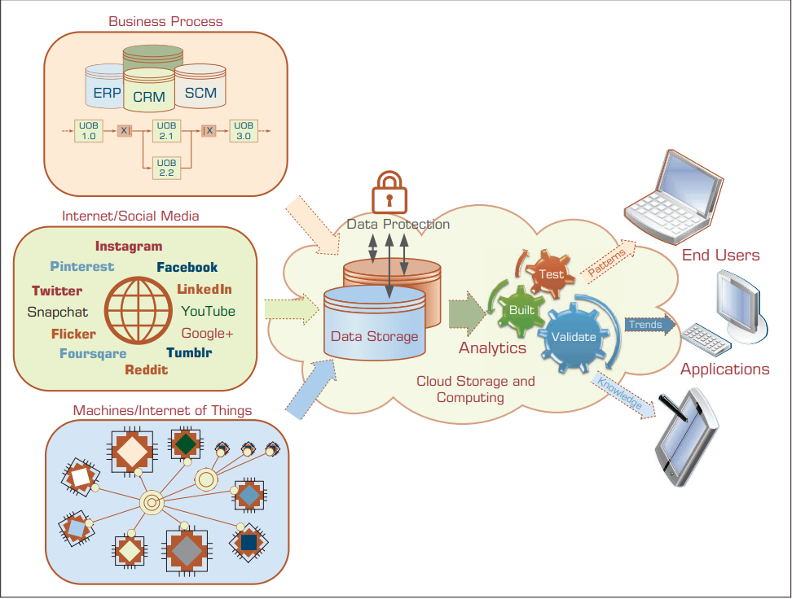

2. Types of Data
At a basic level, data is divided into two main types: Structured and Unstructured.

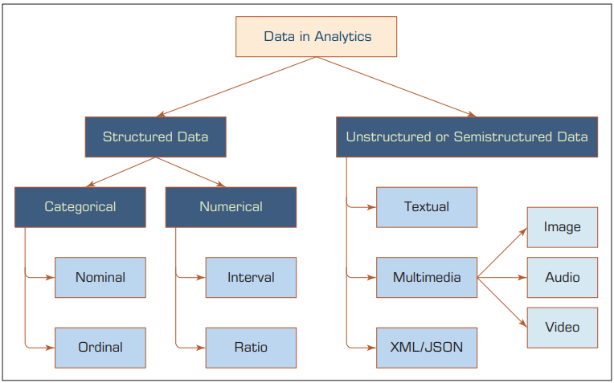

Unstructured Data
This is data that does not have a fixed format. It can be text, images, audio, video, or web content. It is harder for computers to process directly.
Structured Data
This is organized data that fits neatly into rows and columns, like a spreadsheet or database. Data mining tools work with structured data. Structured data is further divided into two groups:
Categorical Data
Categorical data puts things into groups or labels. There are two kinds:
- Nominal data: labels with no order. Example: marital status (single, married, divorced), or colors (brown, green, blue).
- Ordinal data: labels that have a rank or order. Example: satisfaction level (low, medium, high), or education level (high school, college, graduate).

Numeric Data
Numeric data uses numbers to measure something. It can be:
- Integer: whole numbers only. Example: number of children.
- Real (continuous): includes decimal values. Example: temperature, distance.
- Interval data: measured on a scale where the difference between values is meaningful, but there is no true zero. Example: temperature in Celsius.
- Ratio data: like interval but with a true zero point. Example: weight, height, time.

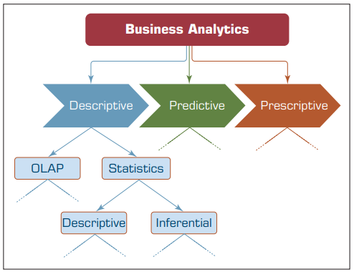

3. Data Preprocessing

Before data can be used for analysis, it usually needs to be cleaned and prepared. This is called data preprocessing. Raw data is often messy, incomplete, or inconsistent. The goal of preprocessing is to turn raw data into well-formed, usable data.
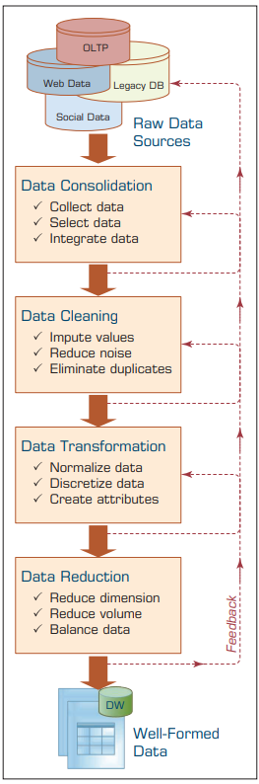
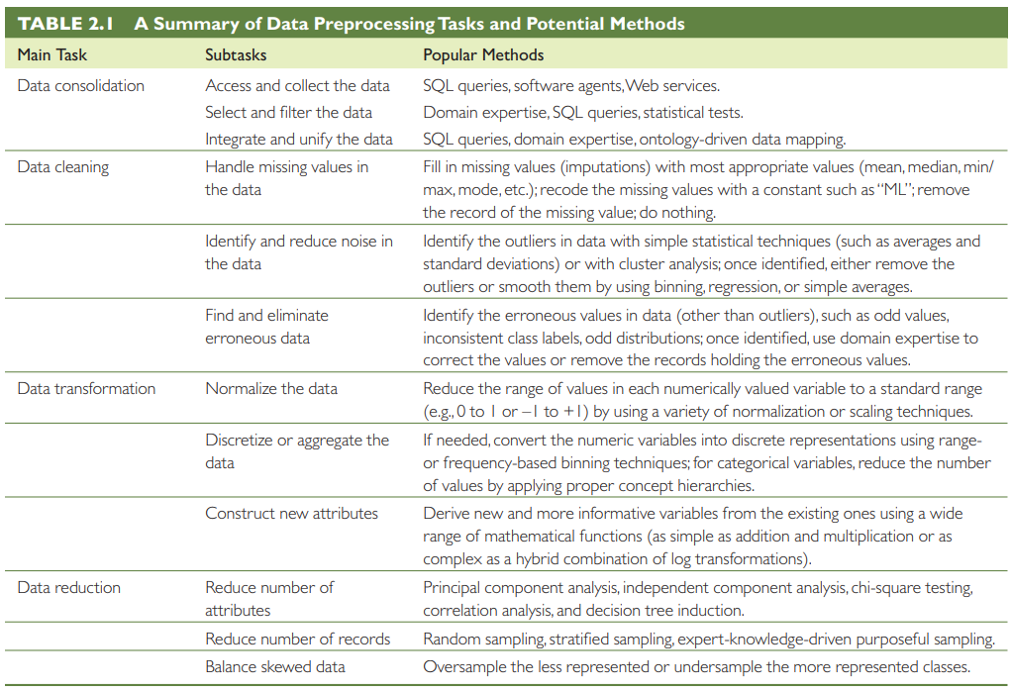



- Data Consolidation: Collect data from different sources, select what is needed, and combine it all together using SQL queries, software agents, or web services.
- Data Cleaning: Handle missing values (fill them in or remove them), reduce noise, and remove duplicate records.
- Data Transformation: Normalize values so they fall in a standard range (0 to 1 or -1 to +1), and create new useful attributes from existing ones.
- Data Reduction: Reduce the size of the data while keeping the important parts, so analysis is faster and easier.

4. Regression Modeling
Regression is one of the most commonly used tools in data analytics. It helps us understand and measure the relationship between variables. In simple terms: regression tries to find how one thing (the output) changes when another thing (the input) changes.

- Hypothesis testing: To check whether two or more variables are related to each other.
- Prediction or forecasting: To estimate future values based on current data.
Simple vs Multiple Regression
- Simple Regression: One input variable predicts one output variable. Example: height predicts weight.
- Multiple Regression: More than one input variable predicts the output. Example: height, BMI, and gender together predict weight.

How the Regression Line is Found
The most common method to find the best-fit line is called Ordinary Least Squares (OLS). It finds the line that minimizes the total error between the actual data points and the predicted values.

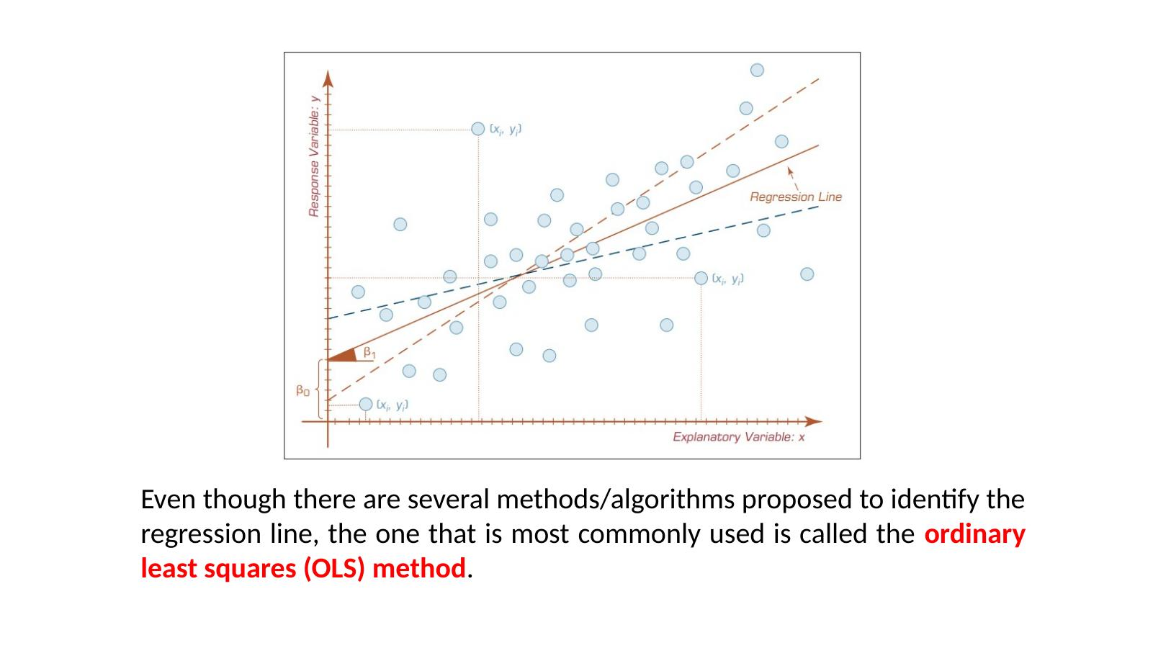

How Do We Know If the Model is Good?
- R-squared (R2): Tells you how much of the variation in the output is explained by the model. A value of 0 means no fit; a value of 1 means a perfect fit.
- Overall F-test: Checks whether the model as a whole is statistically useful.
- Root Mean Square Error (RMSE): Measures the average size of the errors in prediction. Lower is better.

Key Assumptions in Linear Regression
- Linearity: The relationship between input and output is a straight line.
- Independence: Each data point is independent of others.
- Normality: The errors (residuals) follow a normal distribution.
- Constant Variance: The spread of errors stays the same across all values.
- No Multicollinearity: Input variables should not be too closely related to each other.
5. Logistic Regression
Logistic Regression (LR) is used when the output is a category, not a number. Instead of predicting a value, it predicts which group something belongs to. For example: Will a customer buy a product? (Yes or No). Will a patient get a disease? (Positive or Negative).

- The output is a class or category, not a number.
- The original form handles binary output (two choices: yes/no, 0/1, pass/fail).
- A modern version called Multinomial LR can handle more than two categories.
- It is widely used in medicine, social science, and business analytics.
6. Business Reporting
KEY DEFINITION
Definition: Business reporting (also referred to as OLAP — Online Analytical Processing — or Business Intelligence / BI) is an essential component of the larger drive toward improved, evidence-based, and optimal managerial decision making. It involves transforming raw organizational data into actionable reports and summaries for decision makers.

6.1 Purpose and Importance
Decision makers require accurate, timely, and contextualized information to make well-informed business decisions. Information is essentially the contextualization of data: raw facts become meaningful when organized and interpreted. In addition to statistical methods, information (descriptive analytics) can also be obtained using Online Transaction Processing (OLTP) systems.
Business reporting provides a structured pipeline through which organizational data is transformed into visual reports, dashboards, and summaries that support managerial decisions at all levels of an organization.
6.2 Data Sources
The foundation of business reports is data drawn from both internal and external sources:
- Internal sources: Online Transaction Processing (OLTP) systems such as ERP, CRM, and SCM platforms that record day-to-day operations.
- External sources: Market data, social media feeds, government publications, and third-party databases.
6.3 The ETL Process
Creating business reports involves the ETL process, which prepares and loads data into a centralized data warehouse before reporting tools generate the final outputs.
Step | Full Name | Description
Extract (E) | Data Extraction | Pull data from various OLTP systems and other internal/external sources.
Transform (T) | Data Transformation | Clean, format, normalize, and restructure the data for consistency and usability.
Load (L) | Data Loading | Load the processed data into a central data warehouse repository.
Report | Report Generation | Use BI/reporting tools to generate dashboards, charts, and analytical summaries.

6.4 Business Reporting Flow
The complete flow from raw transactional data to managerial decisions follows a well-defined pipeline:
- Business functions generate transactional records and exception events.
- These records are stored in data repositories (data warehouses).
- BI reporting tools process the warehouse data into visual reports and dashboards.
- Decision makers consume these reports to determine appropriate actions.

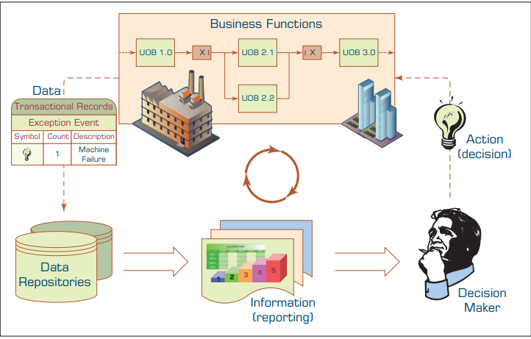
Figure 2: Slide 17 — Business Reporting Process Flow Diagram: From Transactional Data to Decision Making (Source: Lecture Slide, Page 17)
7. Data Visualization and Dashboards
7.1 Data Visualization
KEY DEFINITION
Definition: Data visualization (also called information visualization) is defined as "the use of visual representations to explore, make sense of, and communicate data." Although the term "data visualization" is commonly used, what is typically depicted in visualizations is information — not raw data — since information represents the aggregation, summarization, and contextualization of data (raw facts).

The primary goal of data visualization is to leverage the human visual system to enable rapid perception of patterns, trends, correlations, and anomalies within large and complex data sets. Effective visualizations translate abstract numerical data into intuitive graphical forms that are immediately comprehensible to decision makers.
7.2 Different Types of Charts and Graphs
Charts and graphs are the primary tools of data visualization. Different chart types serve different analytical purposes. The selection of an appropriate chart type depends on the nature of the data and the analytical question being addressed.
Chart / Graph Type | Best Used For | Example Use Case
Bar Chart | Comparing discrete categories | Sales by product category
Line Chart | Showing trends over time | Monthly revenue over a year
Pie / Donut Chart | Showing proportions of a whole | Market share by company
Scatter Plot | Showing correlation between two variables | Height vs. Weight
Histogram | Showing frequency distribution | Distribution of exam scores
Heat Map | Showing density or intensity across two dimensions | Website click patterns
Box Plot | Showing statistical distribution and outliers | Salary range by department
Bubble Chart | Three-variable comparison (x, y, and size) | GDP, life expectancy, population
Treemap | Hierarchical data as nested rectangles | Budget breakdown by department
Gantt Chart | Project timelines and scheduling | Project management tasks
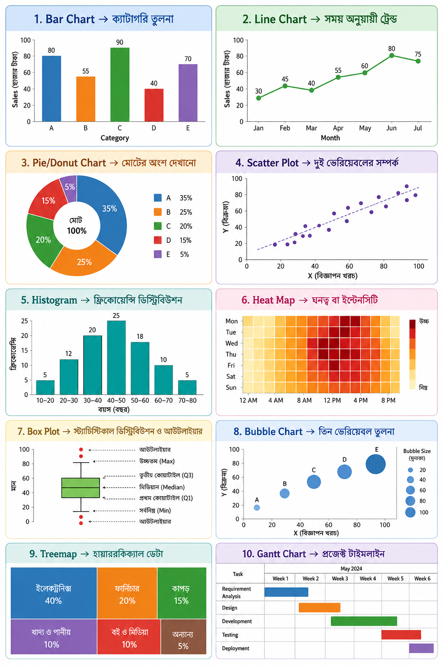
7.3 The Emergence of Visual Analytics
KEY DEFINITION
Visual Analytics: A discipline that combines interactive data visualization with analytical techniques, enabling users to explore, analyze, and communicate insights from large, multi-dimensional data sets stored in data warehouses. Visual analytics goes beyond traditional charts by supporting interactive exploration across multiple dimensions and millions of records.

As noted by Seth Grimes (2009), there is a growing palette of data visualization techniques and tools that enable users of business analytics and BI systems to better communicate relationships, add historical context, uncover hidden correlations, and tell persuasive stories that clarify and call to action.
7.3.1 Key Challenges in Visualization
In BI and analytics, the fundamental challenges for visualization have revolved around the intuitive representation of large, complex data sets with multiple dimensions and measures:
- Dimensionality limitation: Typical charts and graphs involve only two dimensions (x and y axis), sometimes three. This is insufficient for the complexity of modern business data.
- Data volume gap: Data in BI systems resides in data warehouses involving a range of dimensions (e.g., product, location, organizational structure, time), a range of measures, and millions of cells of data.
- Interactivity gap: Static visualizations do not allow users to drill down, filter, or explore data interactively.
- Research response: A number of researchers have developed a variety of new visualization techniques and tools to address these challenges, giving rise to the field of visual analytics.
Feature | Traditional Visualization | Visual Analytics
Dimensions handled | 2–3 dimensions | Many dimensions (multi-dimensional)
Data volume | Small to medium data subsets | Millions of records from data warehouses
Interactivity | Static charts | Interactive drill-down and filtering
Analysis type | Descriptive (what happened) | Exploratory and explanatory
User role | Passive viewer | Active analyst

7.4 Information Dashboards
KEY DEFINITION
Definition: Information dashboards are visual displays of important information that is consolidated and arranged on a single screen so that information can be digested at a single glance and easily explored further. They are common components of most BI and business analytics platforms, business performance management systems, and performance measurement software suites.

According to Eckerson (2006), a well-designed dashboard is not merely a collection of charts; it is a structured, layered information system organized to serve distinct management needs. A well-designed dashboard has three distinct layers:
Layer | Name | Data Type | Purpose
Layer 1 | Monitoring | Graphical, abstracted data | Track key performance metrics (KPIs) at a glance using gauges, traffic lights, and sparklines.
Layer 2 | Analysis | Summarized dimensional data | Analyze the root cause of problems by drilling into summarized data.
Layer 3 | Management | Detailed operational data | Identify specific actions to take in order to resolve problems.

7.4.1 Dashboard Design Principles
Effective information dashboards follow established design principles to ensure clarity, usability, and actionability:
- Single-screen principle: All key information must be visible on a single screen without scrolling, enabling a true "at-a-glance" experience.
- Drill-down capability: Users should be able to click on summary data to explore underlying details.
- Appropriate visual encoding: Choose chart types that match the nature of the data (e.g., gauges for KPIs, line charts for trends, bar charts for comparisons).
- Minimal visual clutter: Avoid decorative elements that do not convey information. Every visual element should serve a purpose.
- Real-time or near-real-time data: Dashboards should reflect current or recent data to support timely decision making.
- Role-based views: Different levels of management (operational, tactical, strategic) may require different dashboard layouts and levels of detail.

Quick Revision Summary — Newly Added Topics
Business Reporting (Section 6)
- Definition: Turning organizational data into structured reports for decision makers; also called OLAP or BI.
- ETL Process: Extract (pull data) → Transform (clean and format) → Load (into data warehouse) → Report (via BI tools).
- Data sources: Internal (OLTP systems: ERP, CRM, SCM) and external sources.
- Goal: Evidence-based, optimal managerial decision making.

Data Visualization (Section 7.1)
- Definition: Use of visual representations to explore, make sense of, and communicate data (technically: information visualization).
- Key distinction: Visualizations show information (aggregated/summarized data), not raw data.
- Purpose: Make patterns, trends, and anomalies immediately visible to decision makers.

Types of Charts and Graphs (Section 7.2)
- Bar chart → compare categories; Line chart → show trends over time.
- Scatter plot → show correlation; Histogram → show frequency distribution.
- Pie chart → show proportions; Heat map → show density/intensity.
- Box plot → statistical distribution; Bubble chart → three-variable comparison.

The Emergence of Visual Analytics (Section 7.3)
- Visual analytics = data visualization + analytical tools + interactivity.
- Limitation of traditional charts: Only 2–3 dimensions; small data subsets.
- Visual analytics advantage: Handles millions of records, multiple dimensions, interactive drill-down.
- Key researcher: Seth Grimes (2009) — coined the "growing palate" of visualization techniques.

Information Dashboards (Section 7.4)
- Definition: A single-screen visual display consolidating key information for at-a-glance decision support.
- Layer 1 — Monitoring: Track KPIs graphically.
- Layer 2 — Analysis: Identify root causes using summarized dimensional data.
- Layer 3 — Management: Determine specific actions from detailed operational data.
- Design principles: Single-screen; drill-down capable; appropriate chart types; minimal clutter; near-real-time data.

8. NumPy
What is NumPy?
NumPy stands for Numerical Python. It is a Python library used to work with arrays (lists of numbers). It is the foundation of almost all data science work in Python. You import it using: import numpy as np (or any short name you choose).

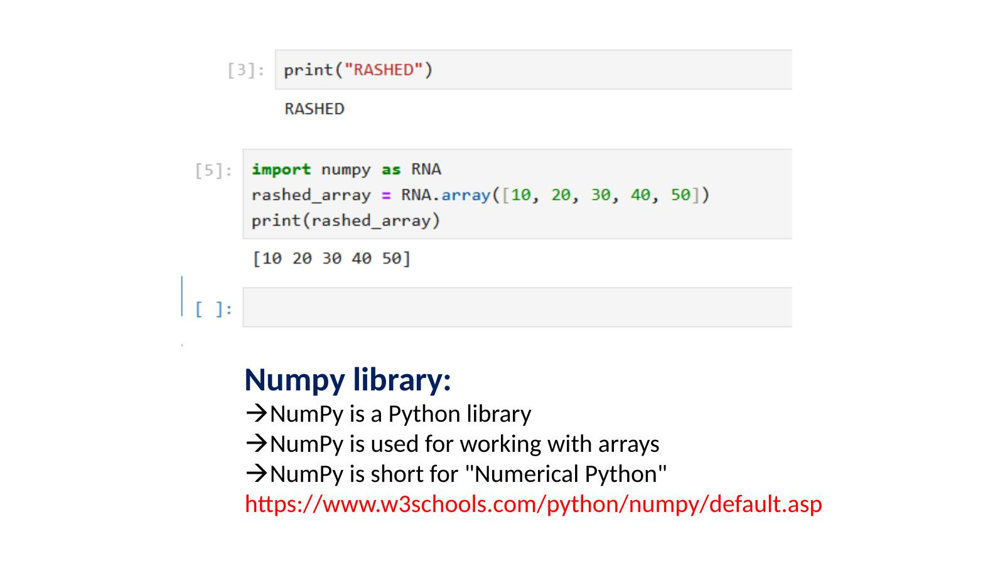

Creating Arrays
An array is a list of numbers stored in order. NumPy lets you create 1D, 2D, and 3D arrays.
- 1D array (one row of numbers): RNA.array([10, 20, 30, 40, 50])
- 2D array (rows and columns, like a table): RNA.array([[10,11,12],[21,22,23],[31,32,33]])
- 3D array (multiple tables stacked): RNA.array([[[10,11,12],[21,22,23]],[[31,32,33],[41,42,43]]])
Note: Python variable names cannot start with a number. For example, "2_RNA" causes a SyntaxError.

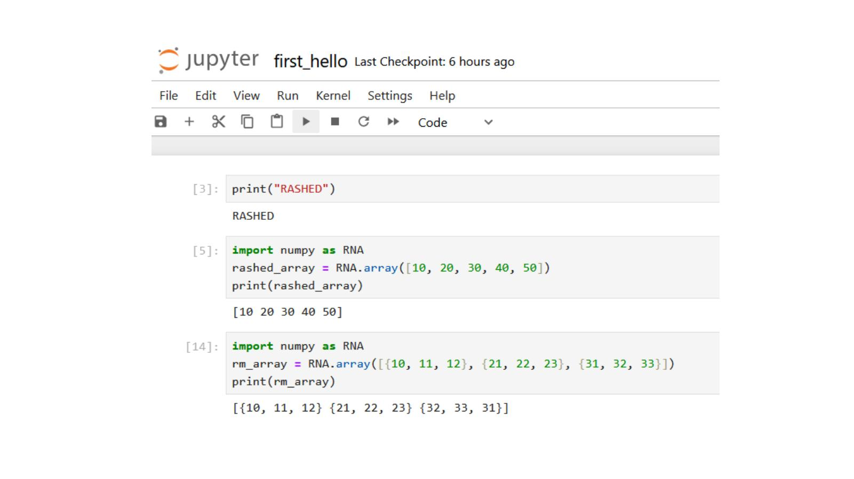

Finding the Shape of an Array
The shape of an array tells you how many rows and columns it has. Use .shape to find it.
Example: A 3D array with shape (2, 2, 3) means 2 blocks, each with 2 rows and 3 columns.

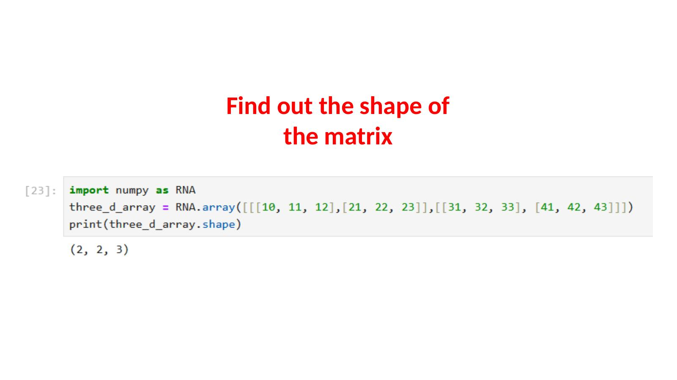

Indexing and Slicing Arrays
You can access any element in an array using its position number (index). Counting starts from 0.
- array[1] gives the second element. Example: rashed_array[1] from [100,200,300,400,500] gives 200.
- array[1:4] gives elements from position 1 up to (not including) position 4. Example: [200, 300, 400].

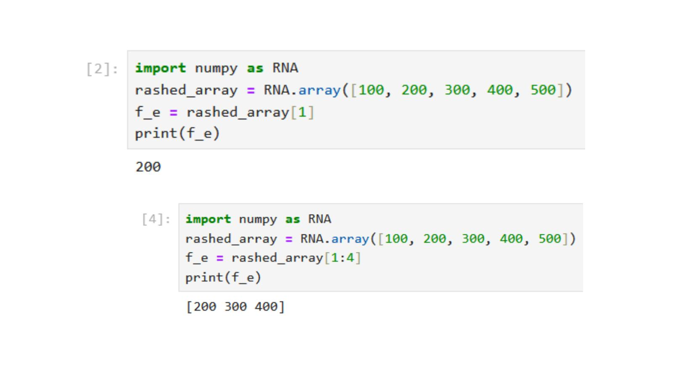

Special Arrays
- Zeros matrix: RNA.zeros(20).reshape(5,4) creates a matrix of 20 zeros arranged in 5 rows and 4 columns.
- Ones matrix: RNA.ones((4,4)) creates a 4x4 matrix filled with ones. You can also change specific positions afterward (broadcast).
- Full matrix: RNA.full((5,6), 99) creates a 5x6 matrix where every cell has the value 99.
- Identity matrix: RNA.identity(5) creates a 5x5 matrix with 1s on the diagonal and 0s everywhere else.

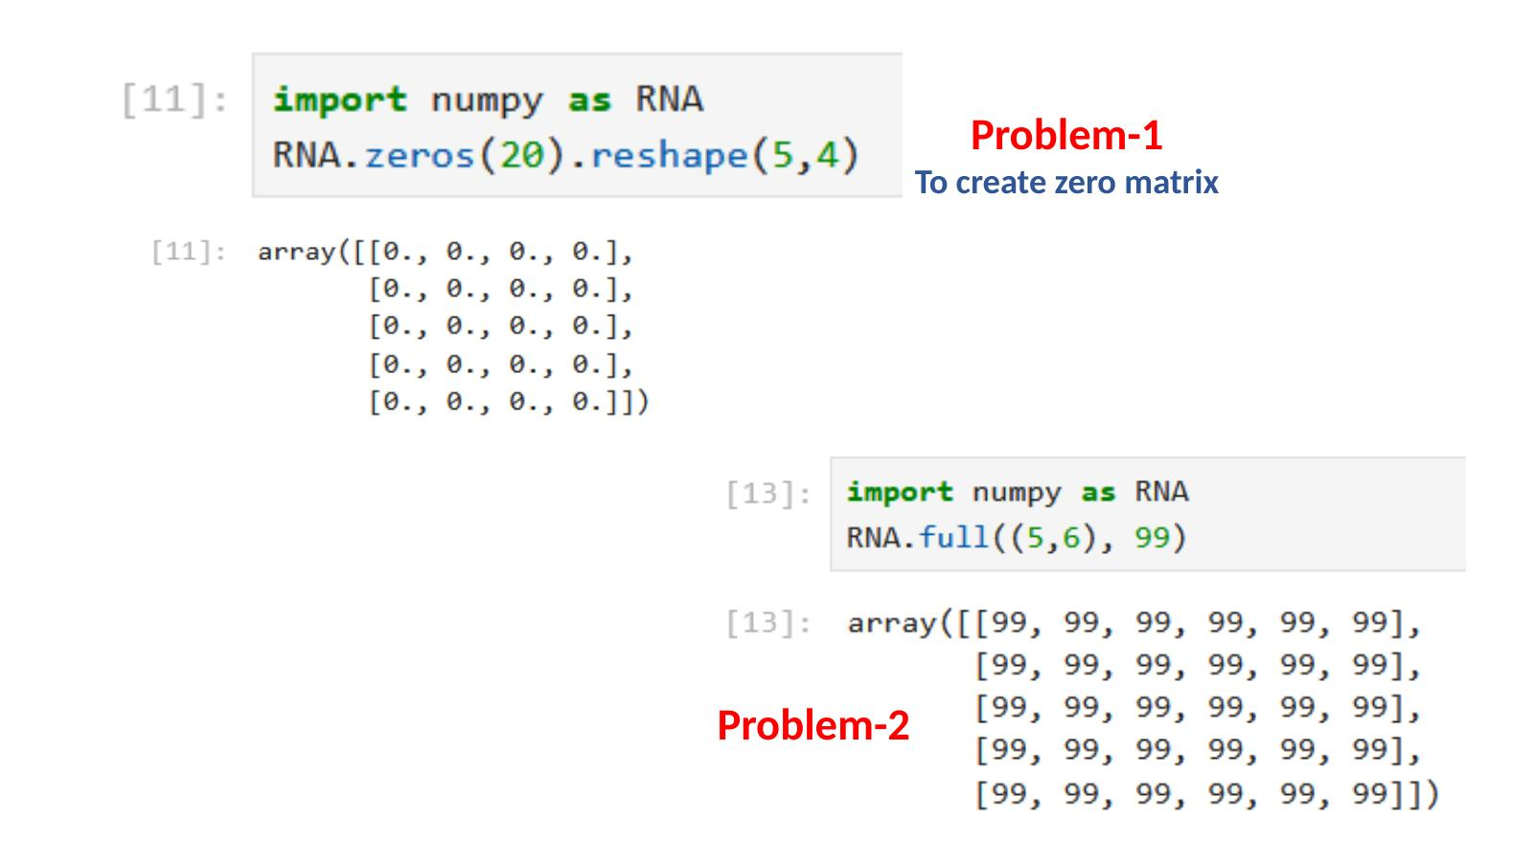

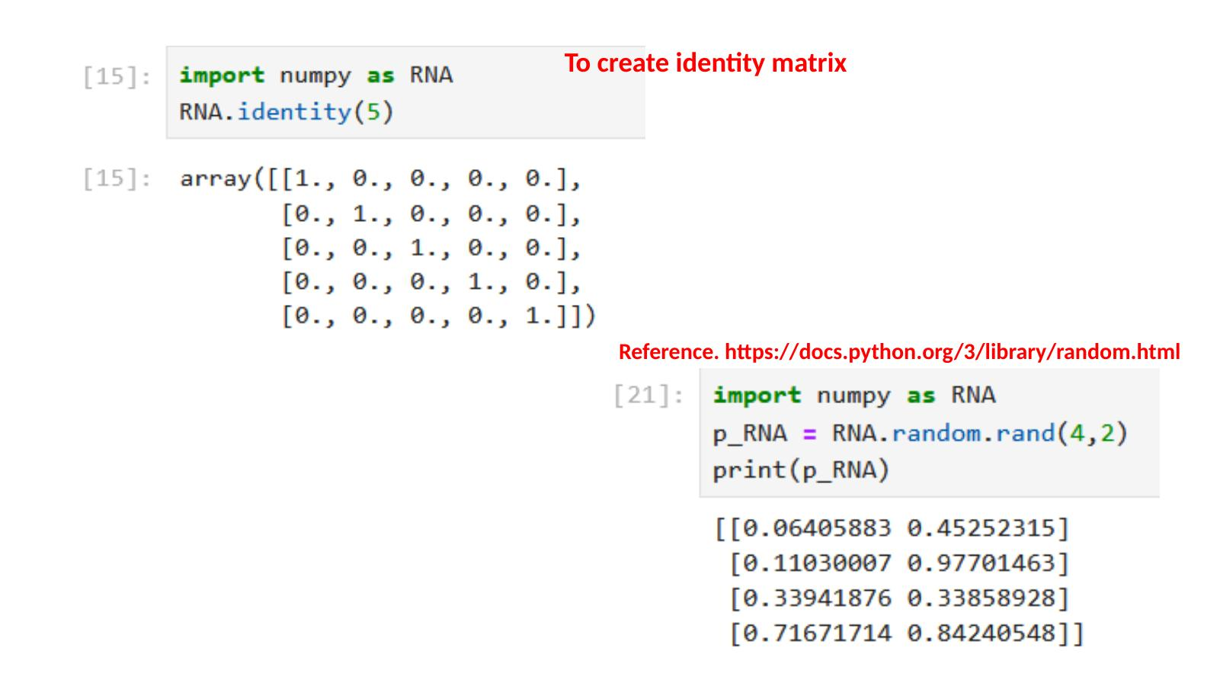

Random Arrays
- RNA.random.rand(4,2): Creates a 4x2 matrix filled with random decimal numbers between 0 and 1.
- RNA.random.randint(10, 100, 12): Creates an array of 12 random whole numbers between 10 and 99.
- RNA.arange(12): Creates an array from 0 to 11.
- RNA.arange(2, 12, 2): Creates an array starting at 2, ending before 12, stepping by 2. Result: [2, 4, 6, 8, 10].

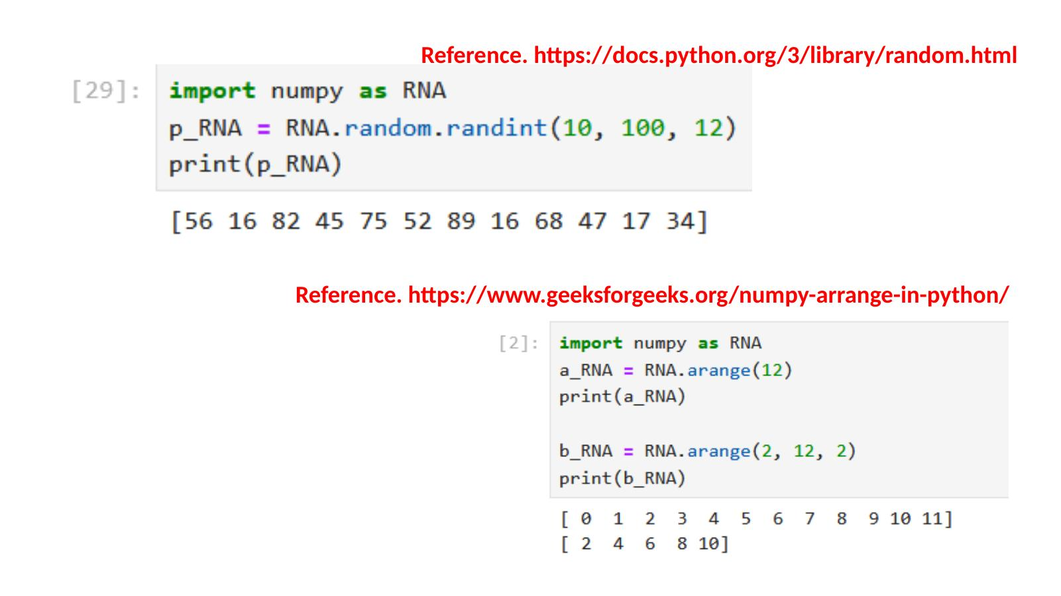

Math Operations on Arrays
- RNA.sum(array): Adds up all values. Example: sum of [20,30,10,40] = 100.
- RNA.mean(array): Finds the average. Example: mean of [20,30,10,40] = 25.0.
- RNA.max(array): Finds the largest value. Example: max of [20,30,10,40] = 40.
- RNA.min(array): Finds the smallest value.
- RNA.sqrt(array): Finds the square root of each element. Example: sqrt of [25,9,16,100] = [5,3,4,10].
- RNA.std(array): Finds the standard deviation (how spread out the values are).
- RNA.sin(), RNA.cos(), RNA.tan(): Trigonometric functions applied to each element.

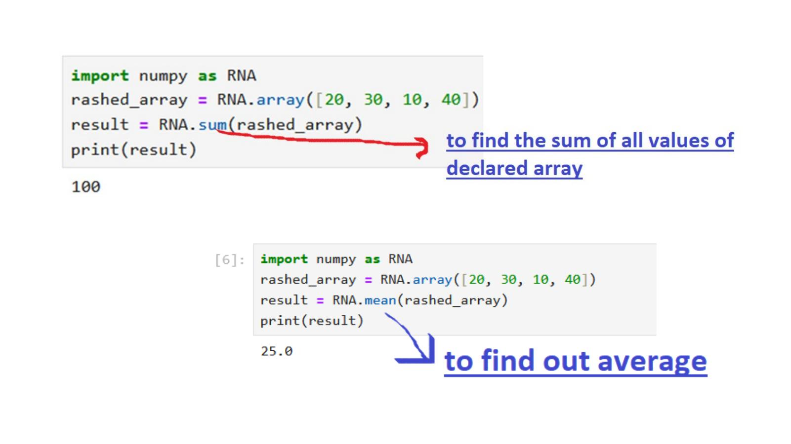

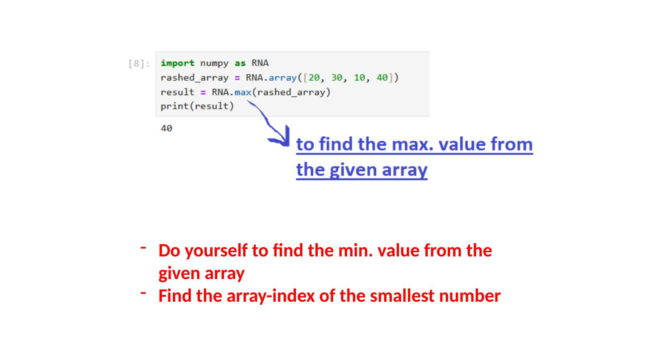

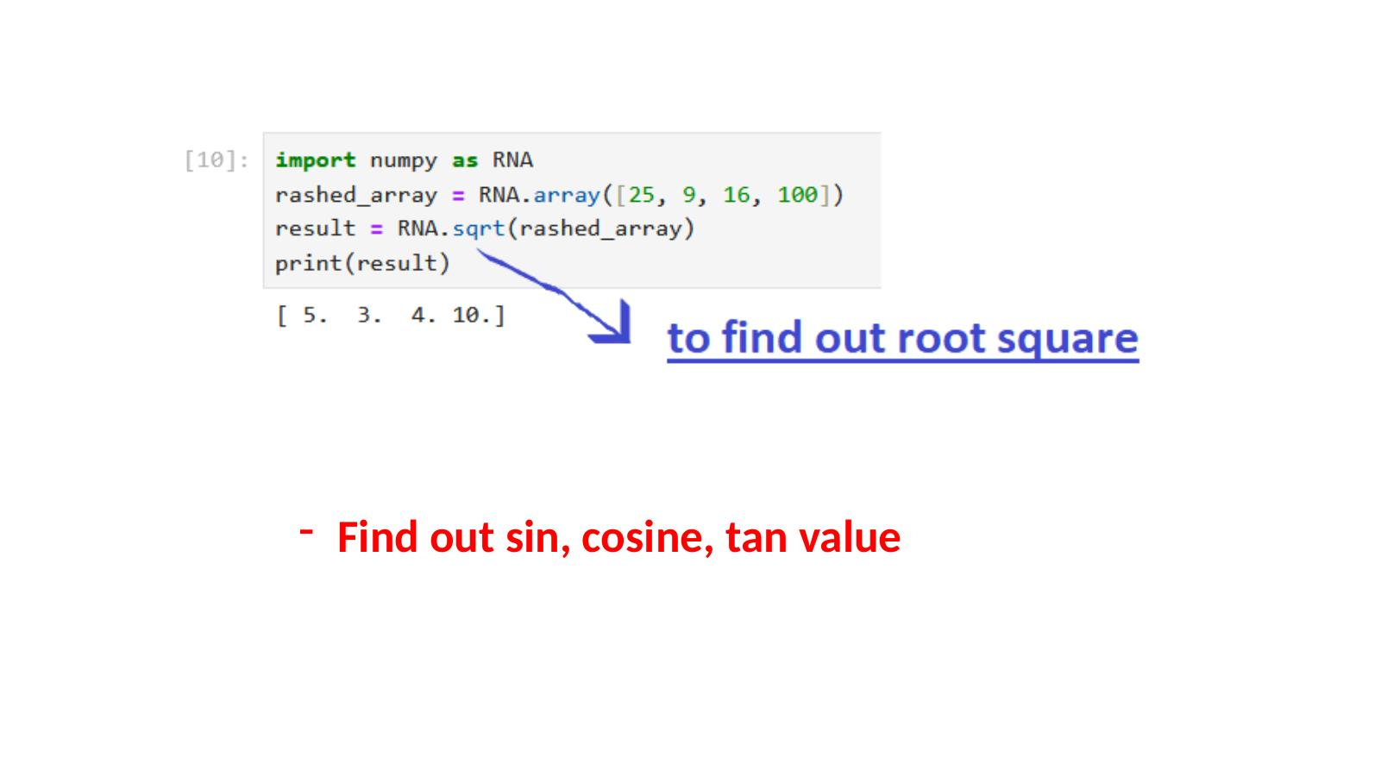

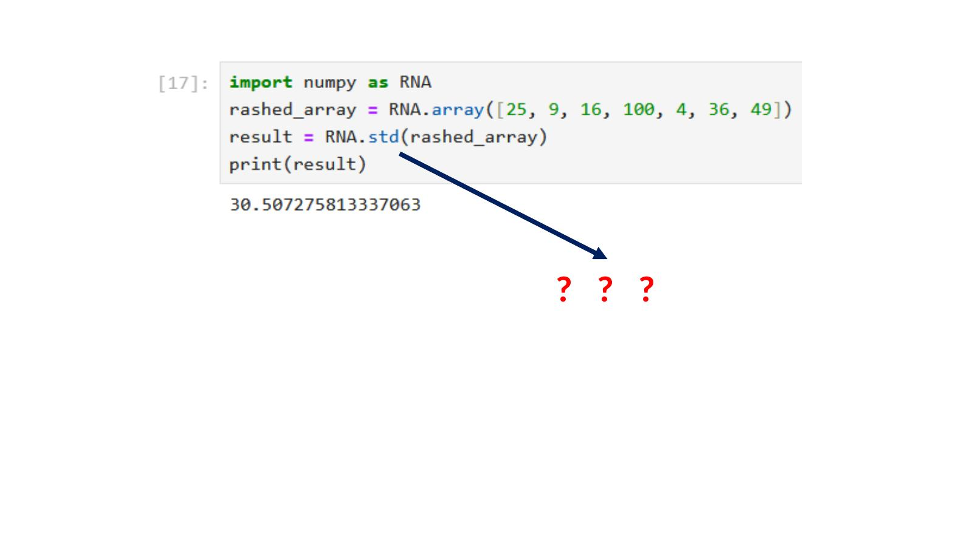

Broadcast Array and Array Arithmetic
You can change more than one index value at a time in an array. This is called broadcasting.
You can also do arithmetic between two arrays of the same size. Each position is added, subtracted, multiplied, or divided with the matching position in the other array.
- Example: _1array = [10,20,30] and _2array = [50,60,70]. Result of _1array + _2array = [60, 80, 100].

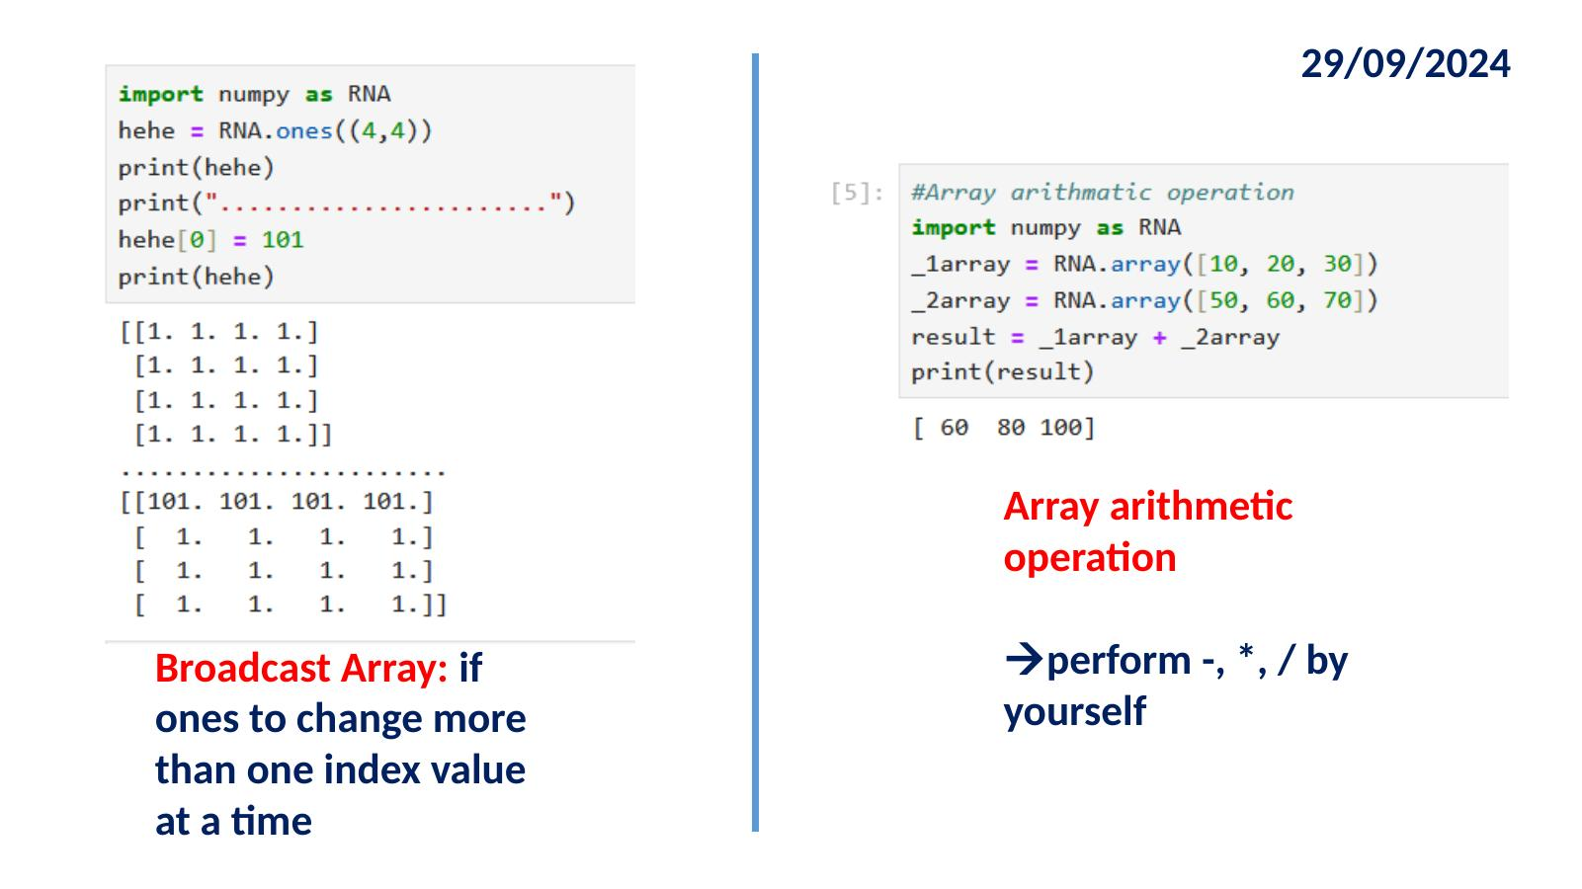

Loading Data from Files
NumPy can read data directly from text files and CSV files into arrays.
From Text File
The genfromtxt() function loads data from a text file. It can handle missing or null values by filtering, removing, or replacing them. It is perfect for data loading and cleaning.
- RNA.genfromtxt("rawdata.txt", delimiter=","): Reads comma-separated data from a text file.
- fileread.astype("int32"): Converts the loaded float values into integers.
- You can also read character data with dtype=str and encoding=None to print text from a file word by word.

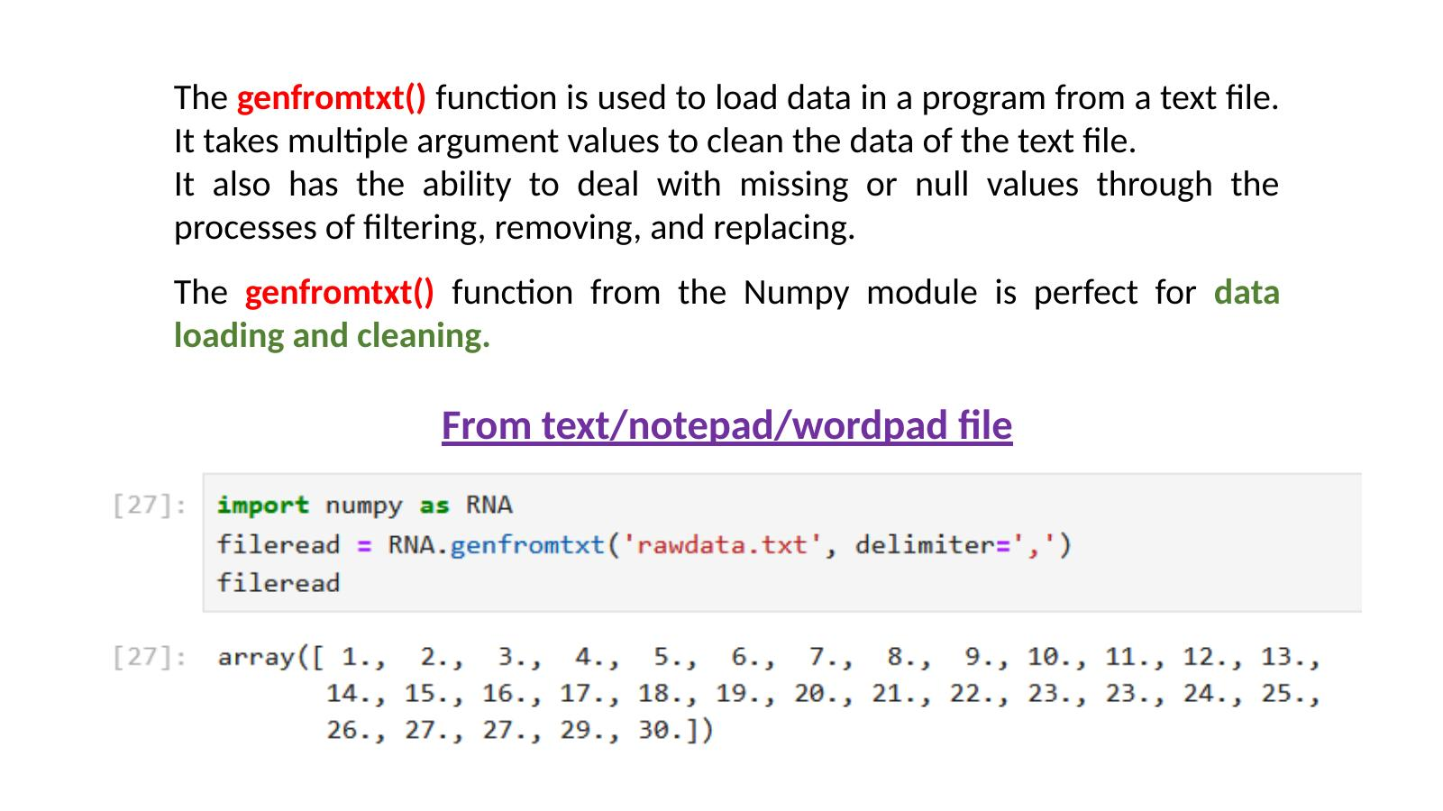

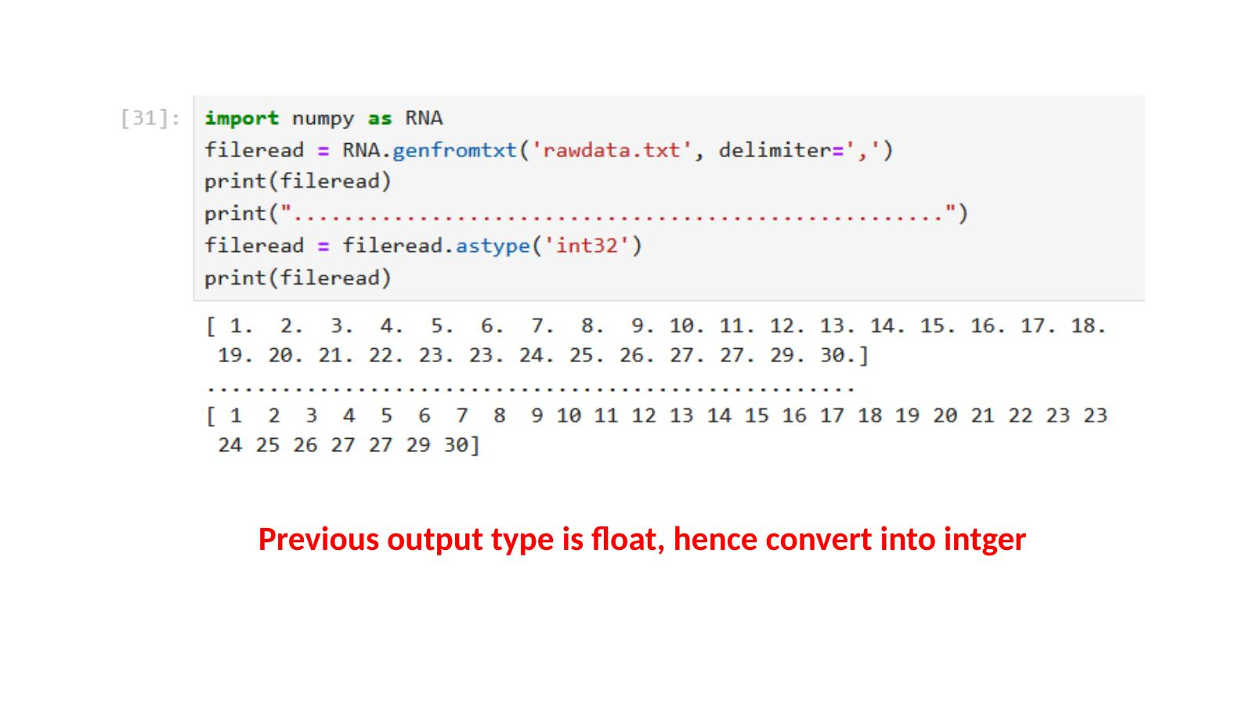

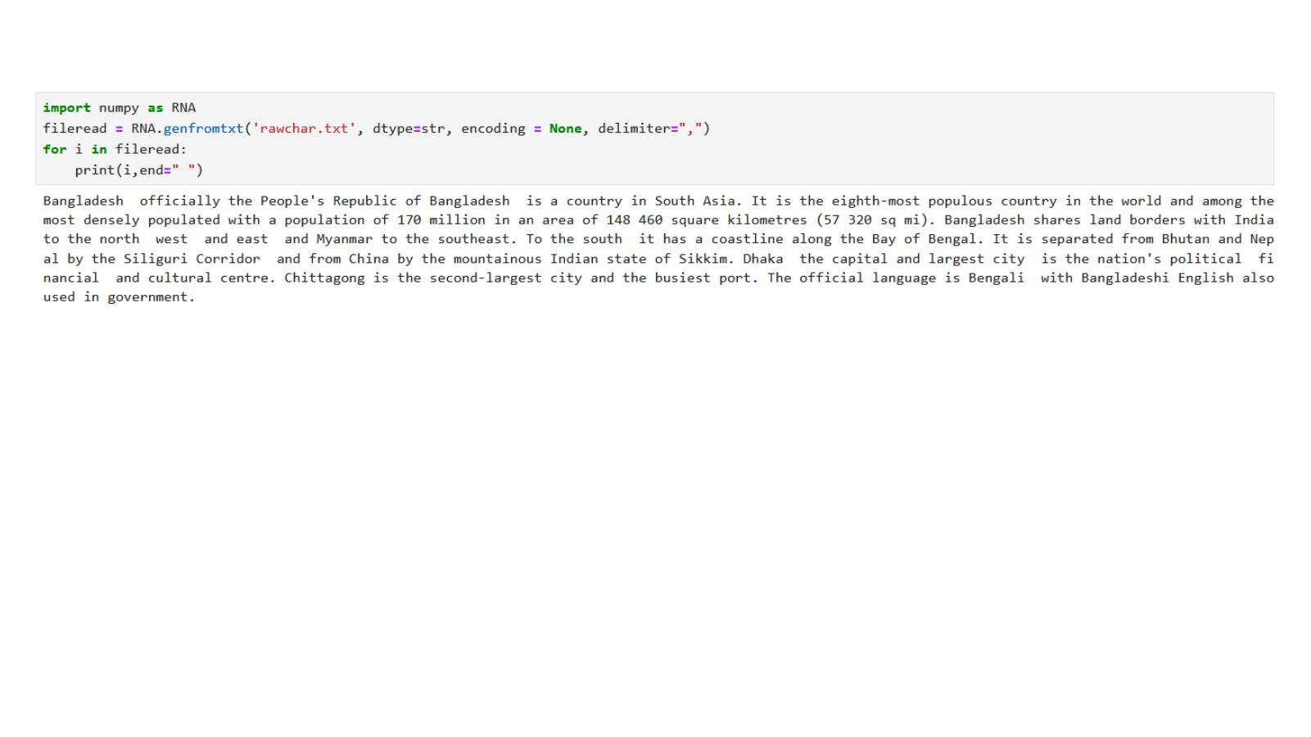

From CSV File
To load data from a CSV file, import the loadtxt library and open the file with open(), then pass it to loadtxt().
- from numpy import loadtxt
- csvread = open("csv1.csv", "rb")
- read = loadtxt(csvread, delimiter=",")
The loadtxt library must be imported separately. The open() function opens the CSV file, and loadtxt reads and parses it into a NumPy array.

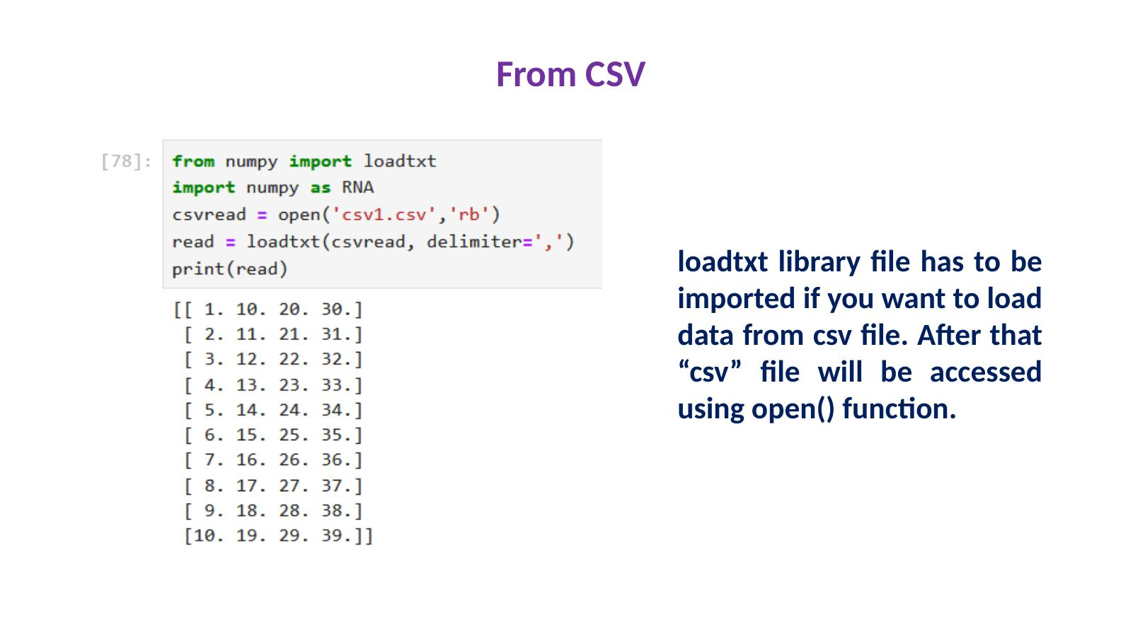

9. Pandas
What is Pandas?
Pandas is a Python library for working with data sets, especially tables (like a spreadsheet). It was created by Wes McKinney in 2008. The name comes from Panel Data and Python Data Analysis. You import it using: import pandas as pd (or any short name you choose).

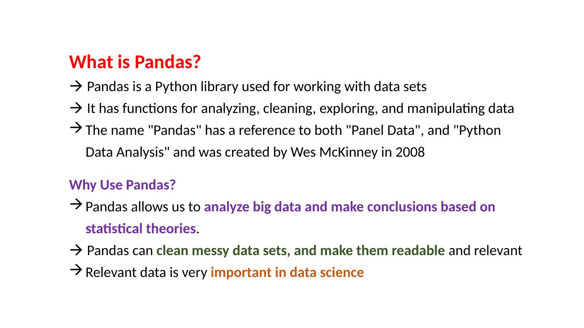

What Can Pandas Do?
Pandas can answer questions about your data such as:
- Is there a correlation between two or more columns?
- What is the average (mean) value of a column?
- What is the maximum or minimum value?
Pandas can also delete rows that are not relevant, or contain wrong or empty (NULL) values. This process is called cleaning the data.

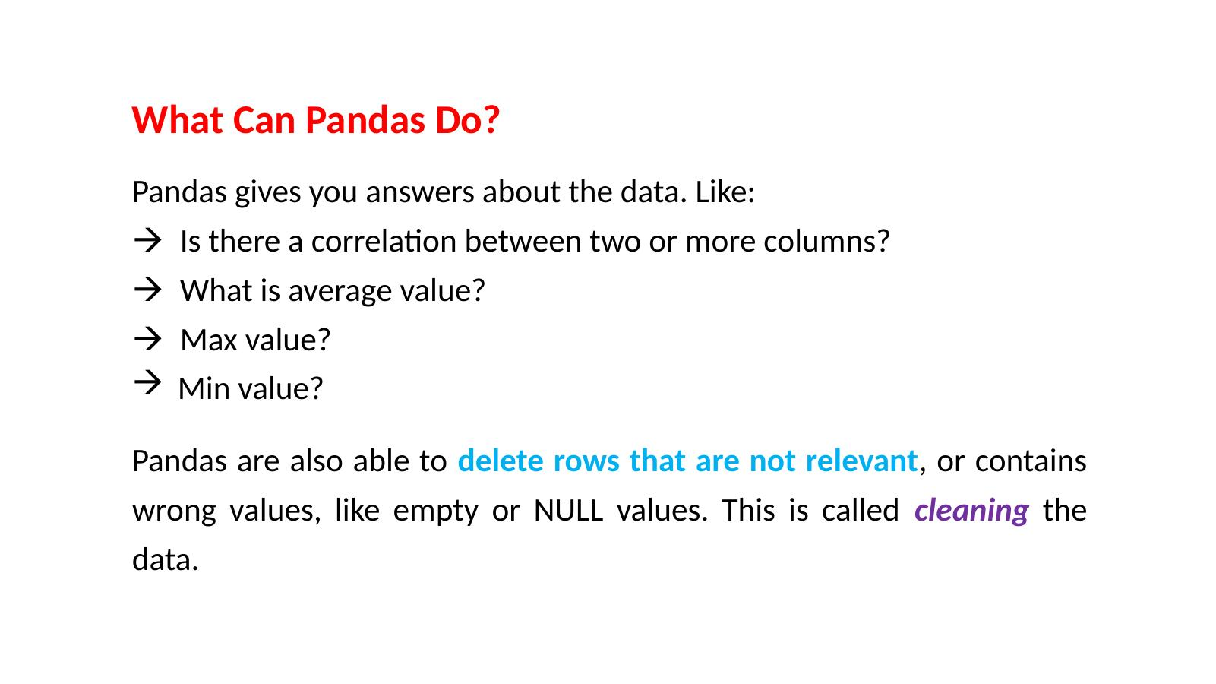

Series and DataFrame
The two main data structures in Pandas are Series and DataFrame.
- Series: A single column of data, like one list of values. You can give it custom labels (index). Example: RPD.Series([10,17,12,23], index=["A","B","C","D"])
- DataFrame: A full table with rows and columns. It is like a 2D spreadsheet. You create it from a dictionary where each key is a column name and the value is a list of data.
By default, rows are numbered starting from 0. You can also give custom row labels using the index parameter.

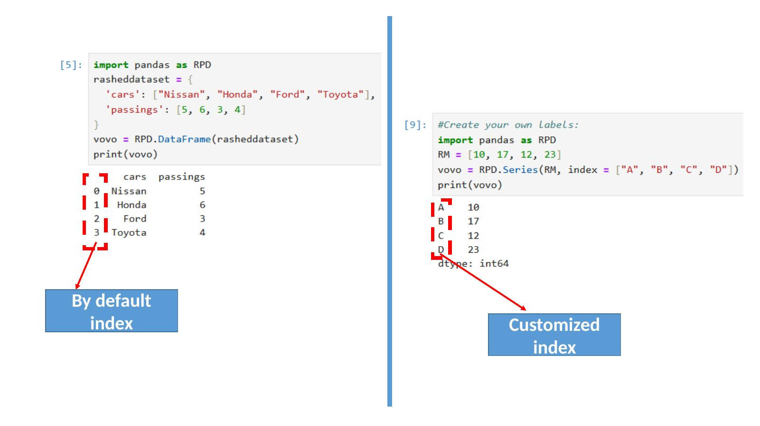

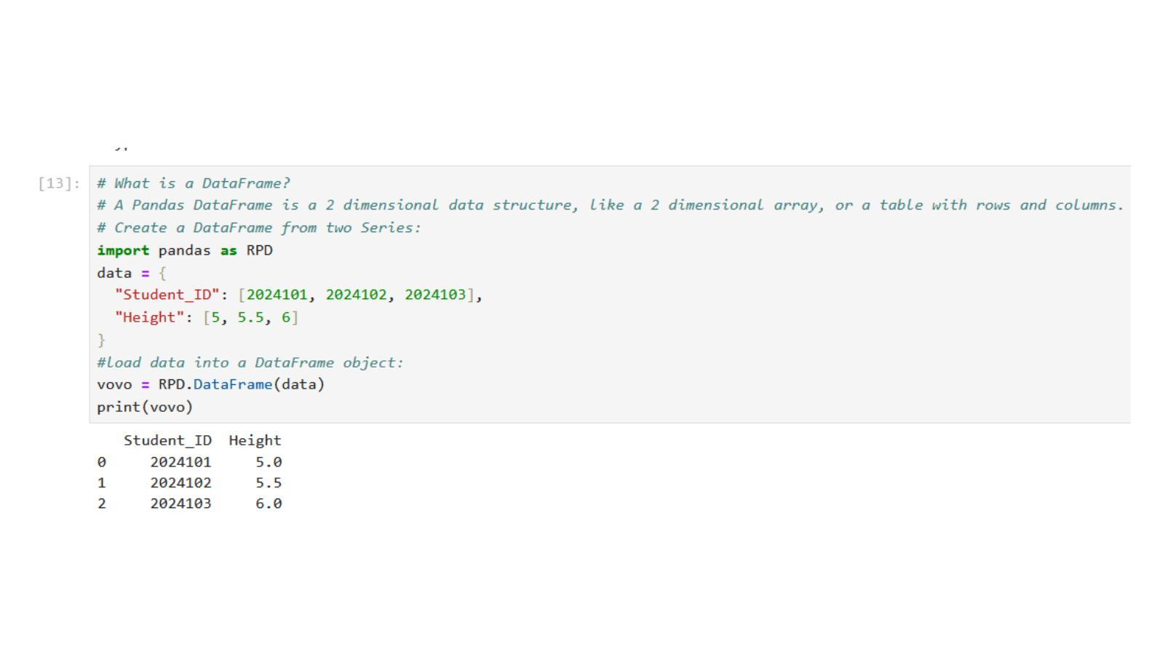

Selecting Specific Rows
Use .loc[] to select specific rows by their index number or label.
- vovo.loc[[0, 1]] prints rows at index 0 and 1.
- You can also give custom row names: RPD.DataFrame(data, index=["i","ii","iii"])

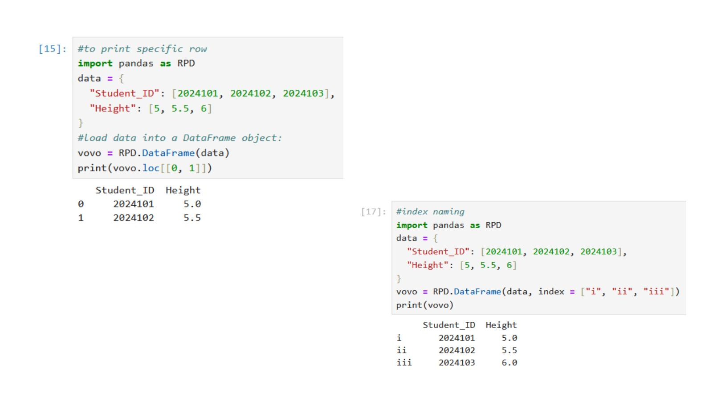

Reading CSV Files with Pandas
Pandas makes it very easy to read data from a CSV file into a DataFrame.
- RPD.read_csv("filename.csv"): Reads the entire CSV file into a table.
- vovo.head(5): Shows the first 5 rows of the table.
- vovo.tail(): Shows the last 5 rows of the table.
- RPD.options.display.max_rows: Shows how many rows Pandas will display at once (default is 60).

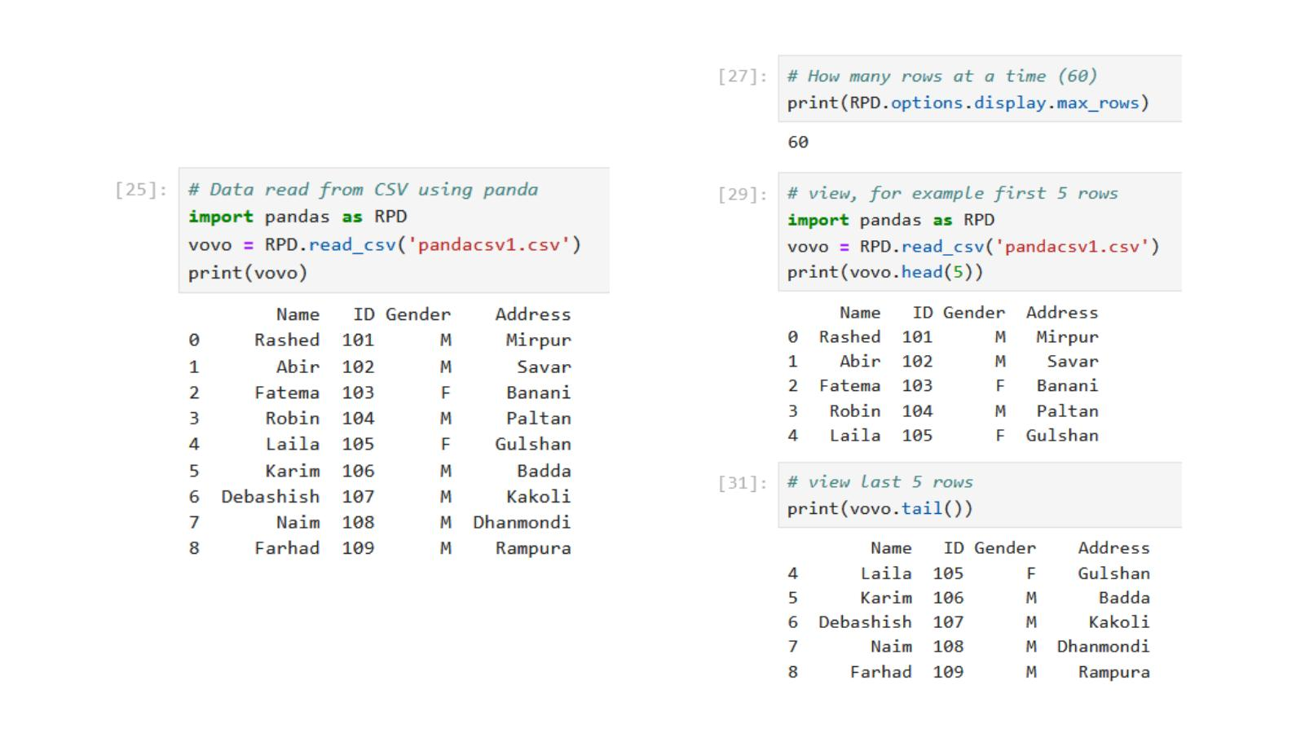

Cleaning Data: Handling Empty Cells
Empty cells in a dataset cause problems in analysis. Pandas gives you several ways to deal with them.
Method 1: dropna()
This removes all rows that have any empty (NaN) cell. It returns a new DataFrame and does not change the original.
- hehe = vovo.dropna()

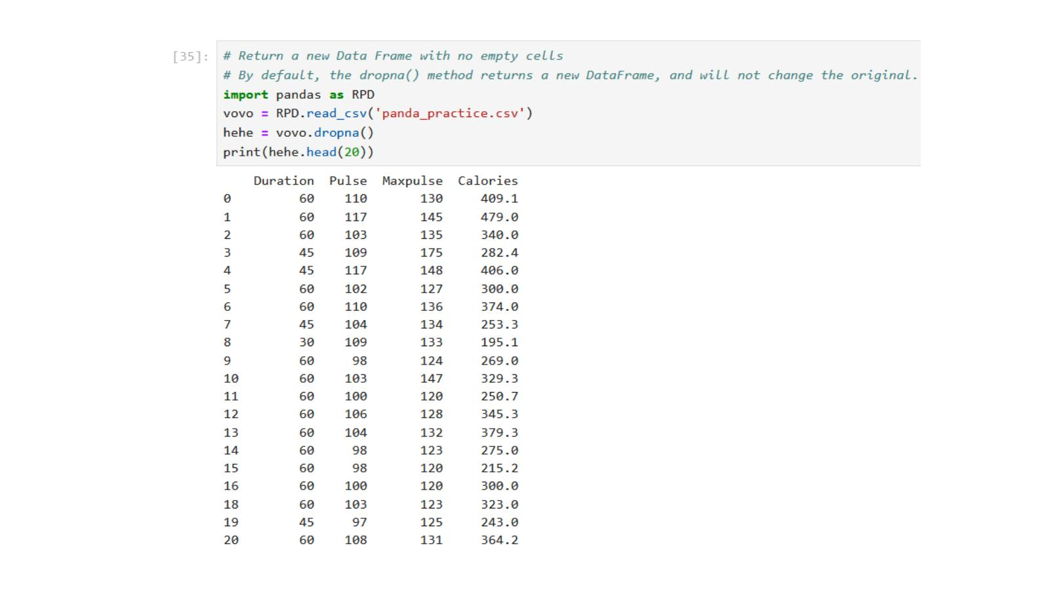

Method 2: fillna()
Instead of removing rows, you can fill empty cells with a value you choose.
- vovo.fillna(130, inplace=True): Fills all empty cells in the whole table with the value 130.
- vovo.fillna({"Calories": 150}, inplace=True): Fills empty cells only in the Calories column with 150.
- vovo.fillna({"Calories": vovo["Calories"].mean()}, inplace=True): Fills empty cells with the average (mean) value of that column. This is a smarter and more common approach.
You can also fill with median or mode. The median is the middle value. The mode is the most repeated value. Use .median() or .mode()[0] in the same way.

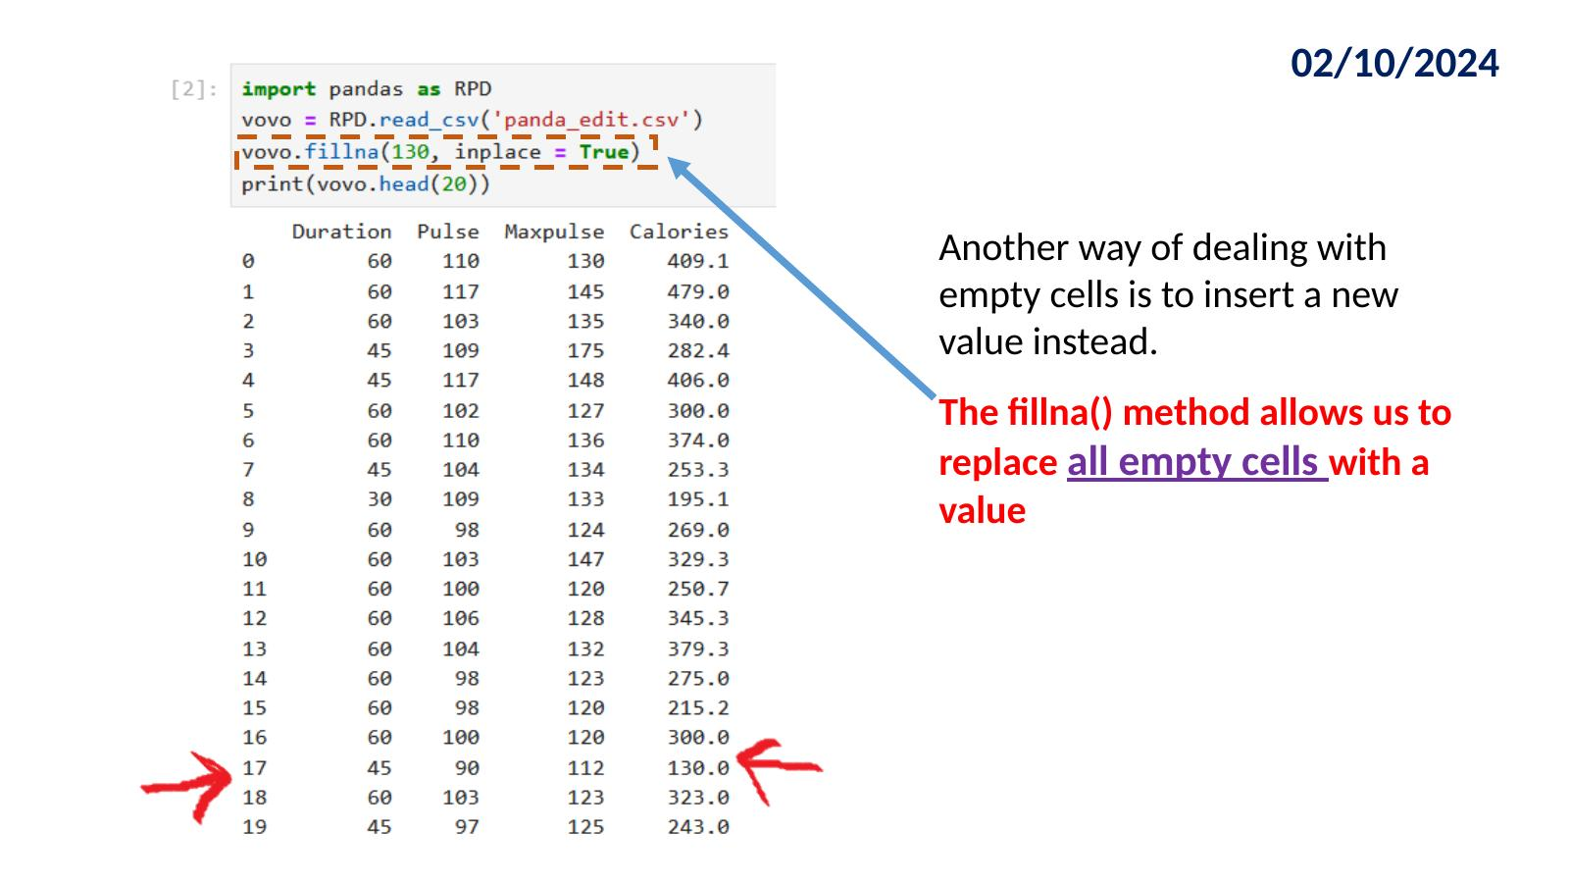

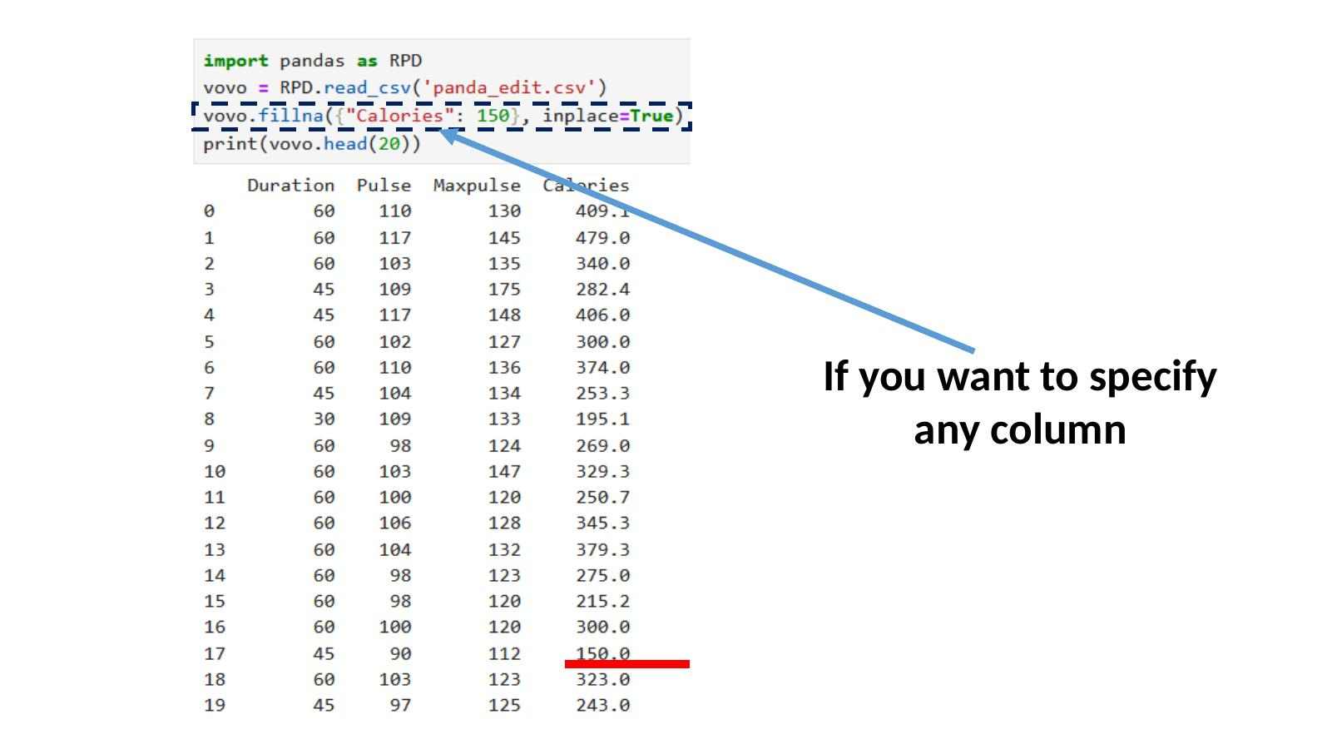

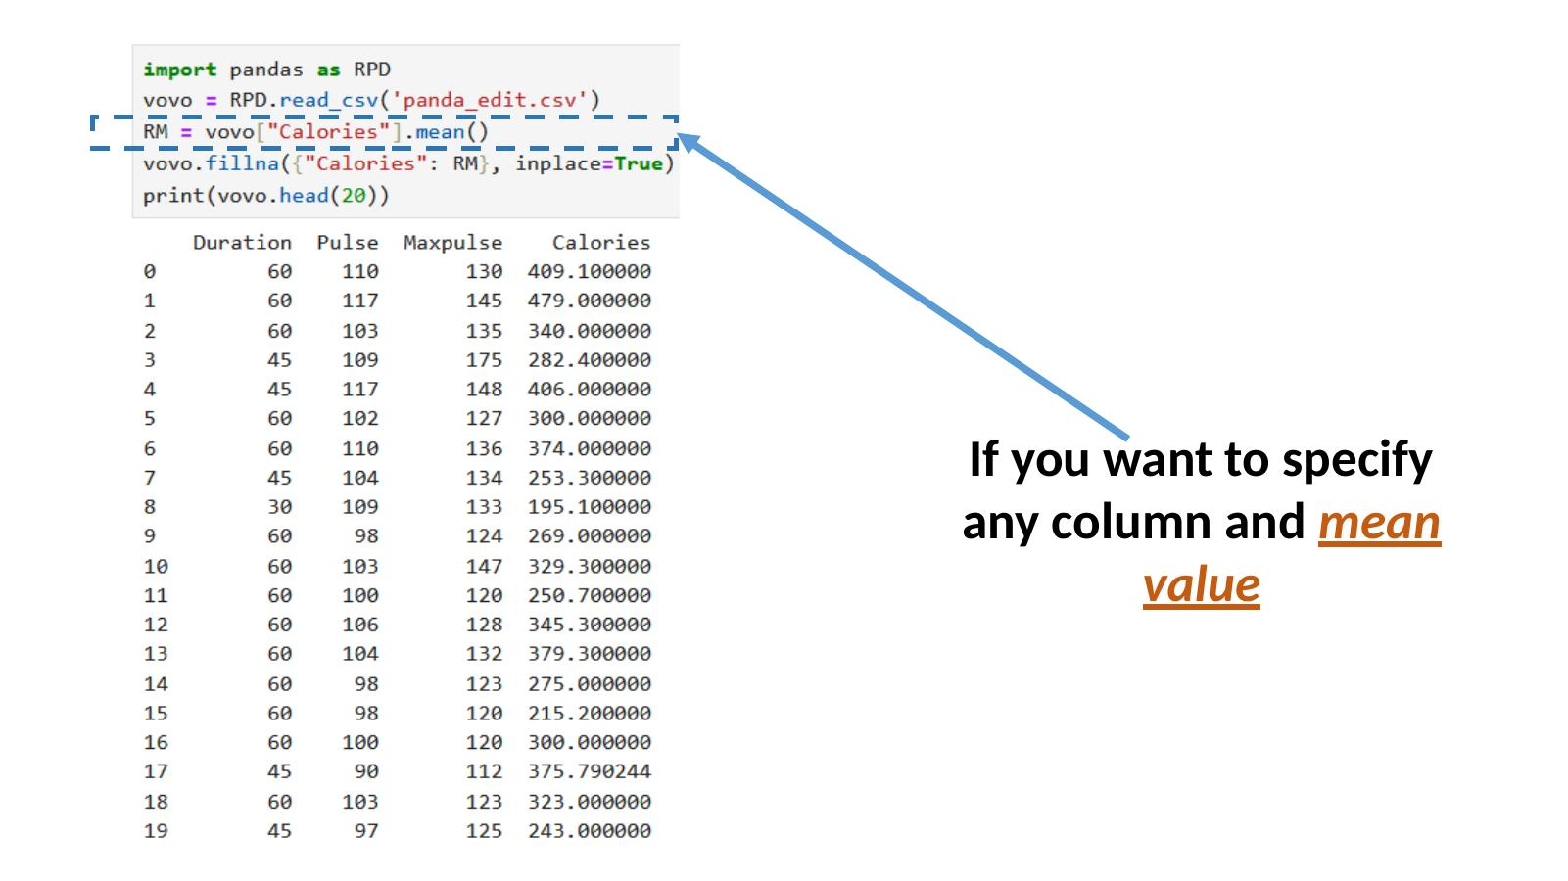

Method 3: Forward Fill and Backward Fill
- vovo.ffill(axis=0): Forward fill. Fills each empty cell with the value from the row above it.
- Backward fill (bfill): Fills each empty cell with the value from the row below it.

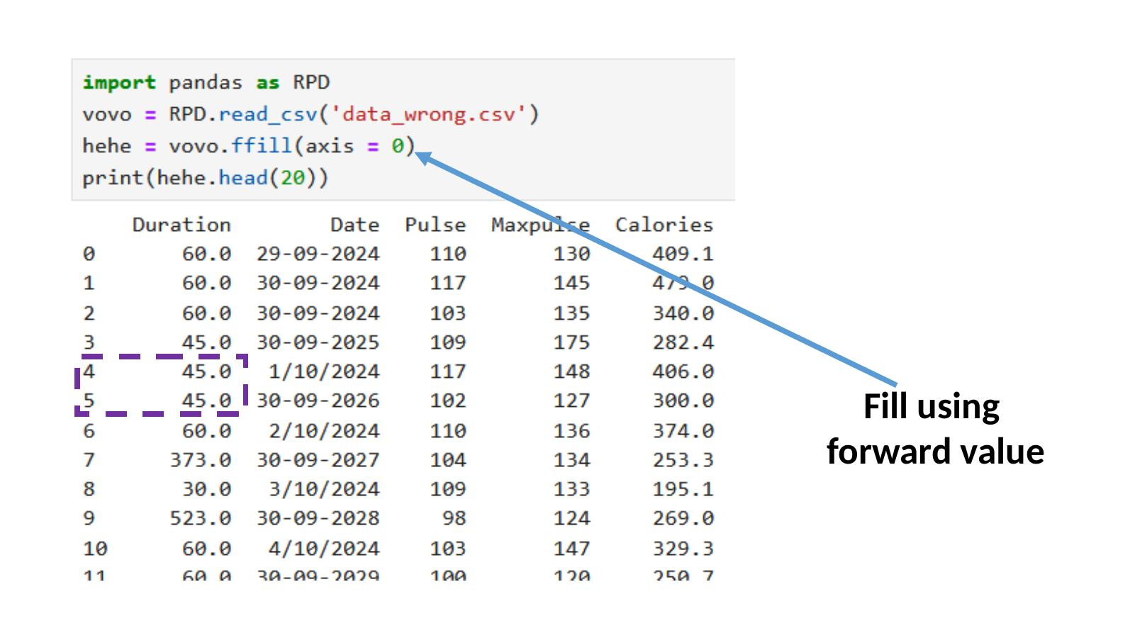

Cleaning Data: Fixing Wrong Values
Sometimes data has wrong values, not missing ones. For example, a Duration value of 373 or 523 that should be 60. You can fix these directly using .loc[].
- vovo.loc[7:9, "Duration"] = 29: Sets rows 7, 8, and 9 in the Duration column to 29.
For larger datasets, use a loop with a condition to find and fix wrong values automatically.
- If Duration is greater than 59, replace it with 22.
You can also drop rows where the value is wrong instead of fixing them.
- vovo.drop(rm, inplace=True): Removes a row that meets a condition.

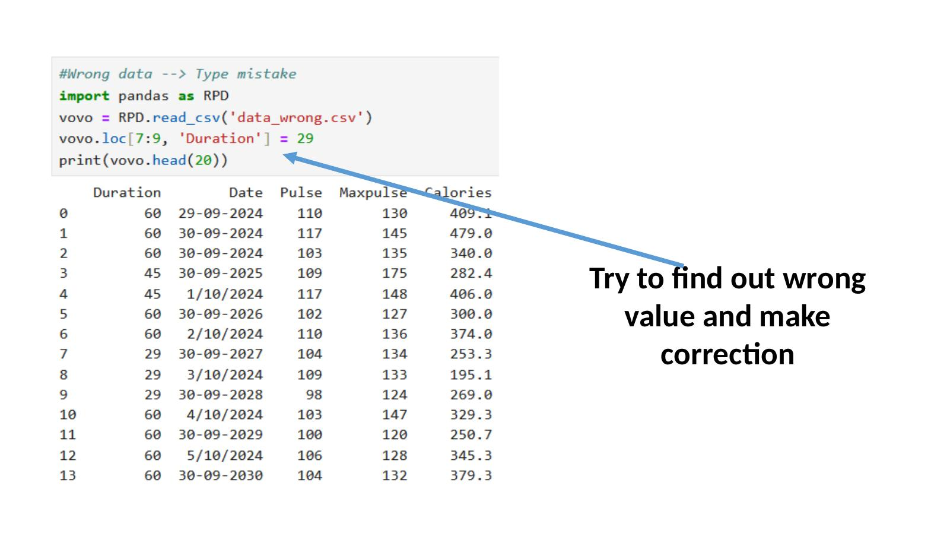

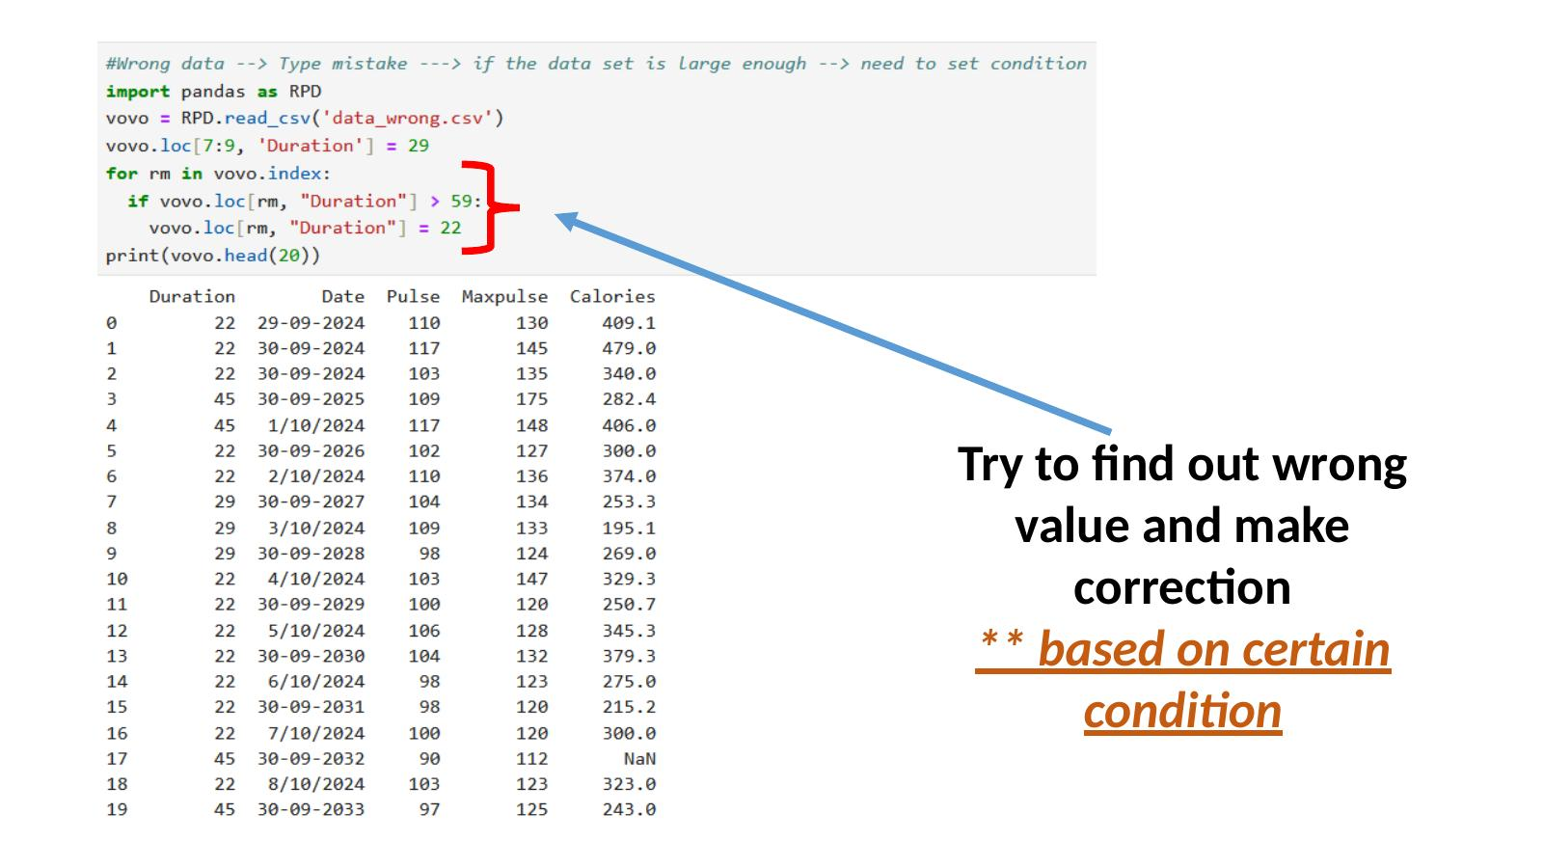

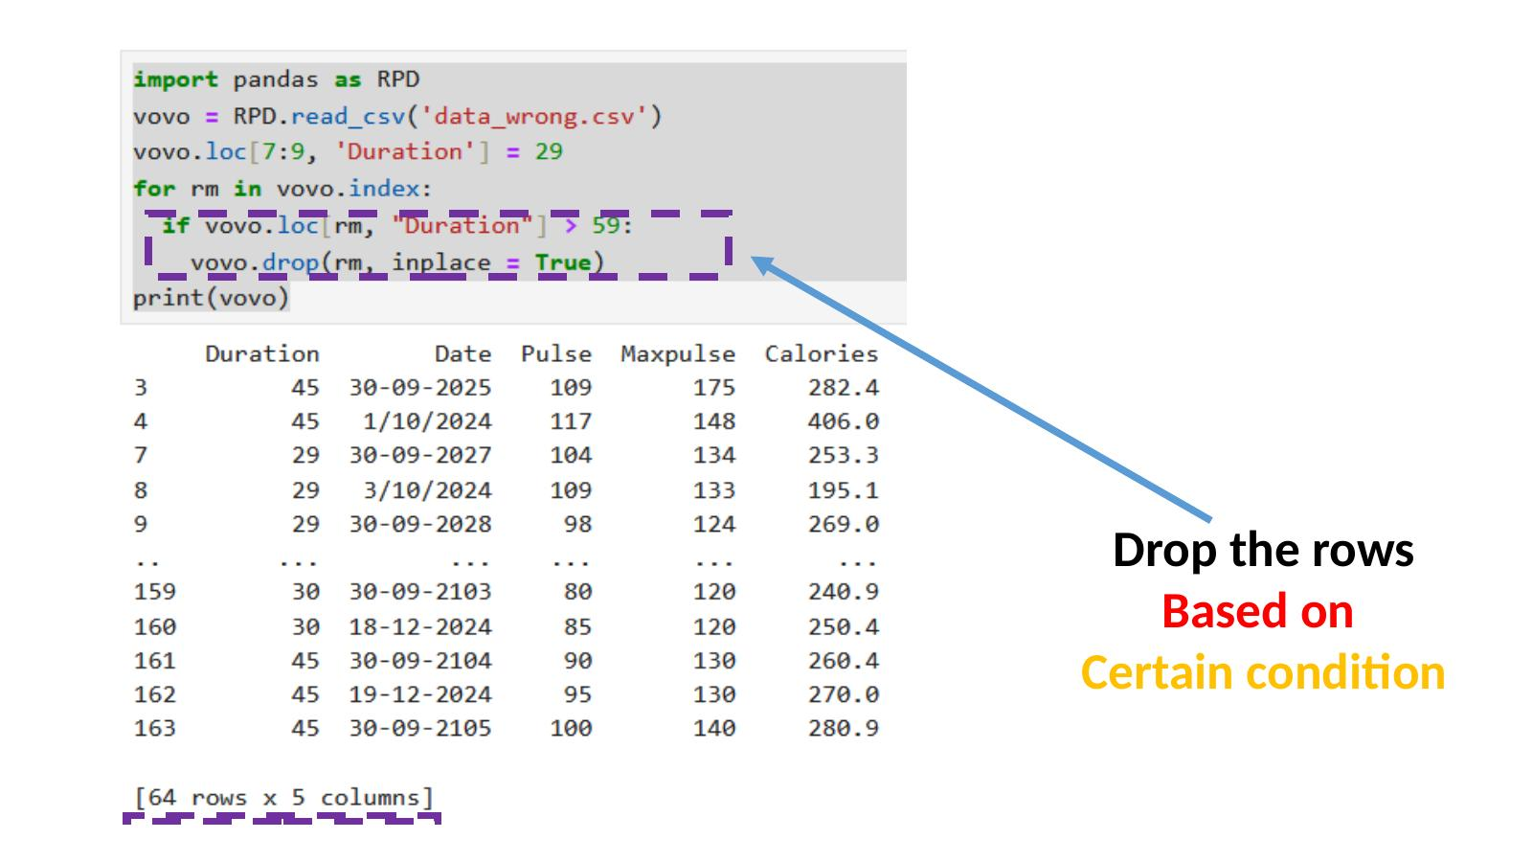

Handling Duplicate Rows
Sometimes the same row appears more than once in a dataset. Pandas helps you find and remove these duplicate rows.
- vovo.duplicated(): Returns True for every row that is a duplicate, and False for rows that are unique.
- bobo.drop_duplicates(inplace=True): Removes all duplicate rows from the table permanently.

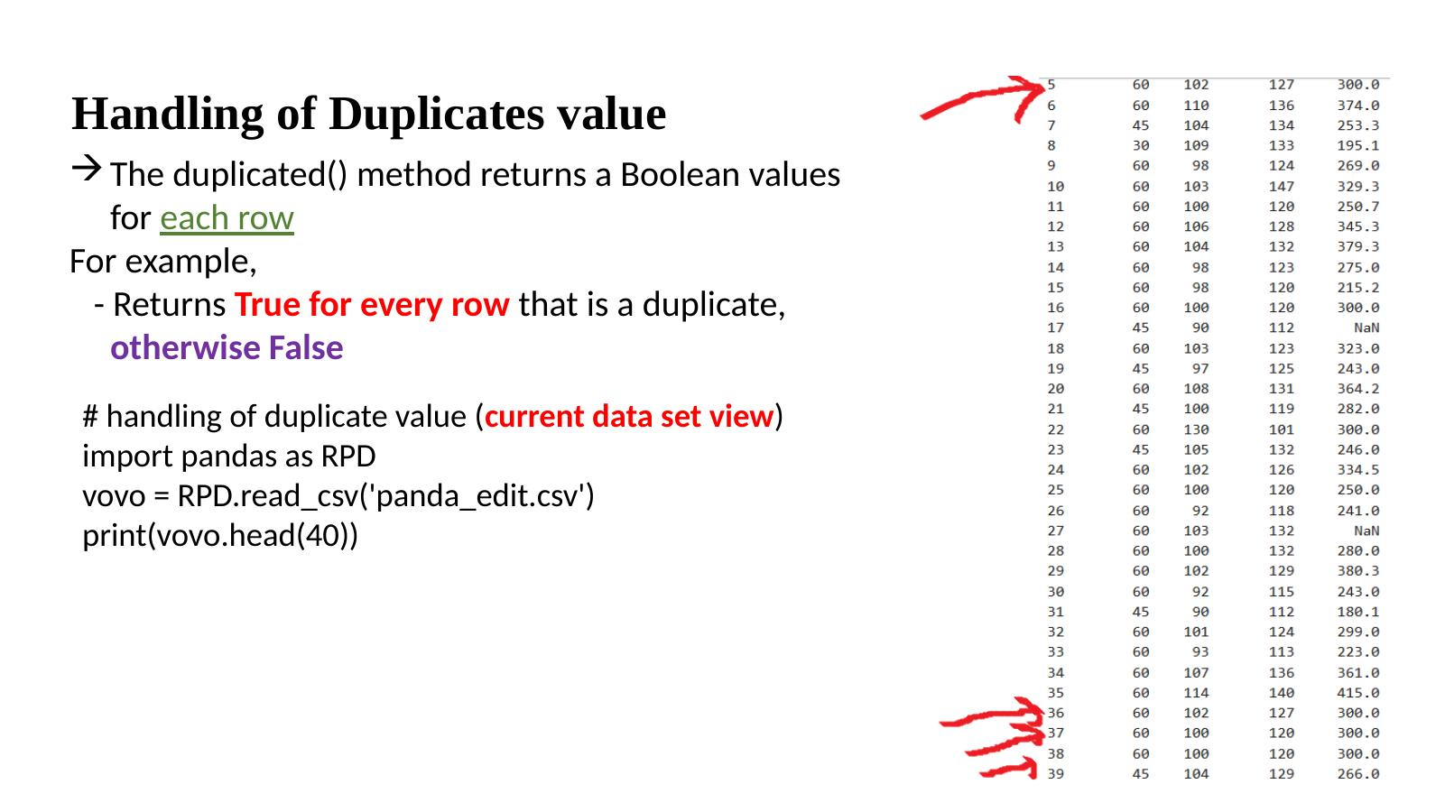

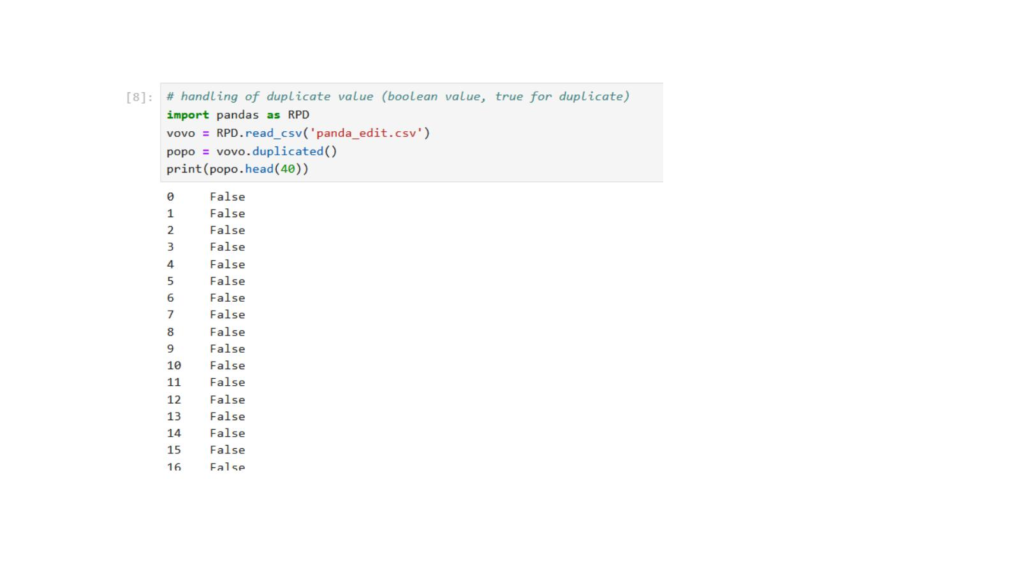

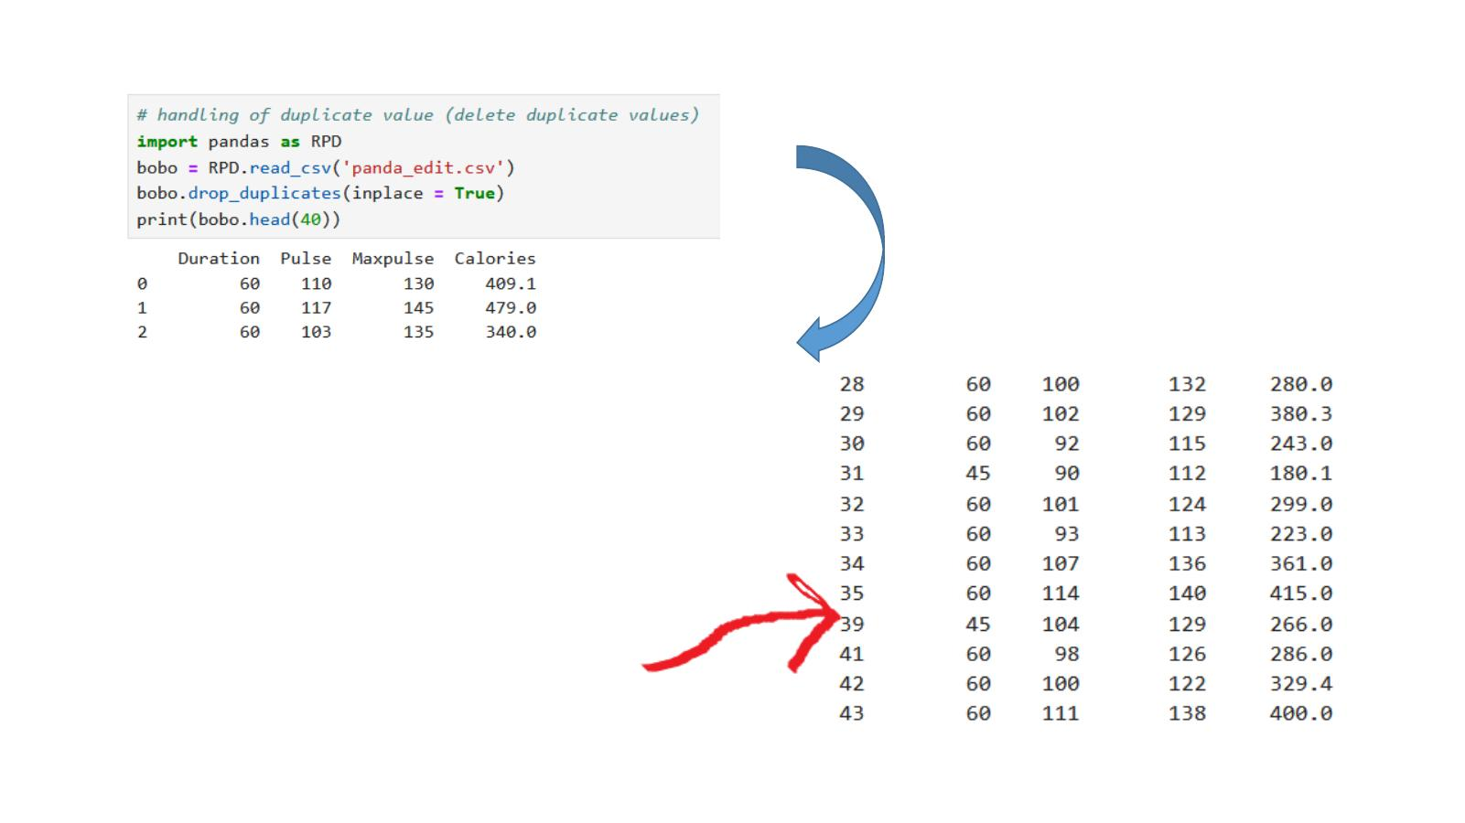

Plotting with Pandas
Pandas has a built-in plot() method to create charts directly from your data. It works together with the matplotlib library to display the chart on screen.
Line Chart
vovo.plot() draws a line chart for all columns in the DataFrame. Each column becomes one colored line on the chart.

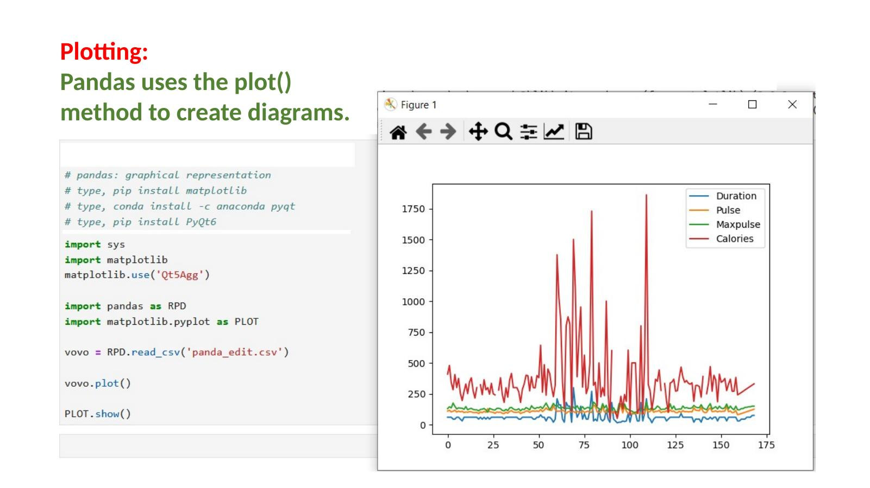

Scatter Plot
A scatter plot shows the relationship between two specific columns as dots on a graph.
- vovo.plot(kind="scatter", x="Duration", y="Calories"): Plots Duration on the x-axis and Calories on the y-axis.

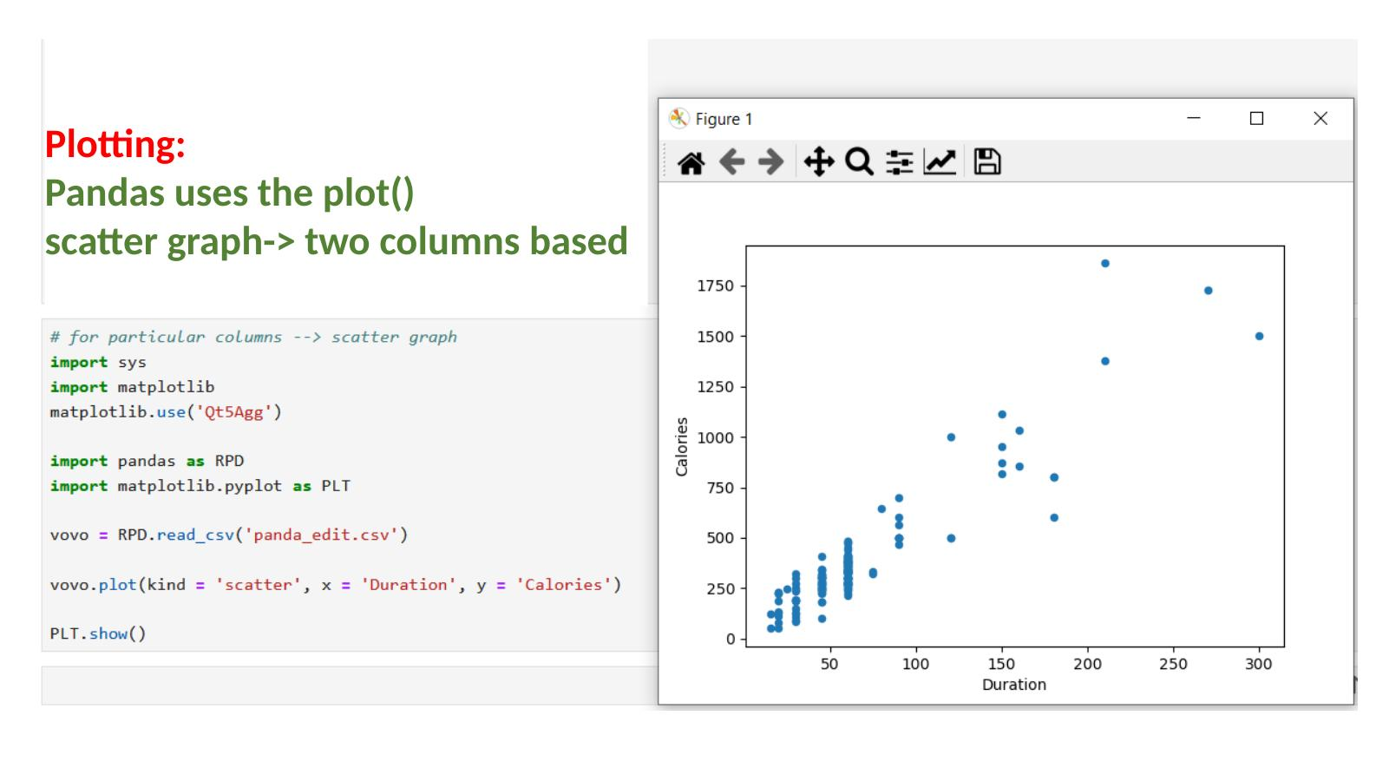

Histogram
A histogram shows how frequently different value ranges appear in one column.
- vovo["Calories"].plot(kind="hist"): Creates a histogram for the Calories column only.

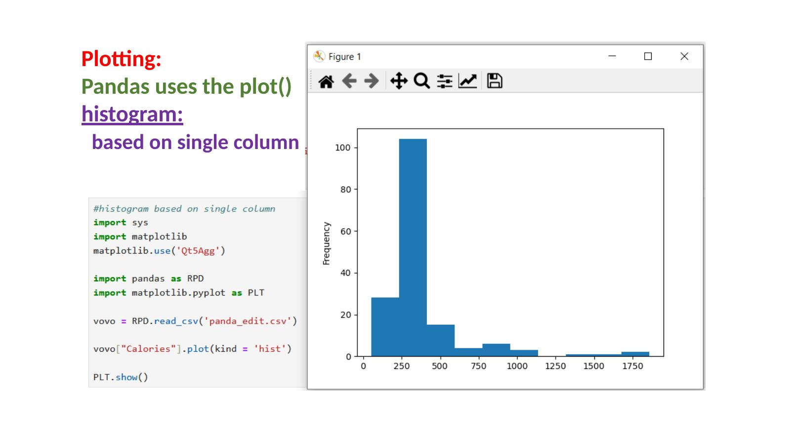

End of Notes

